

**360 DEGREE FEEDBACK SOFTWARE FOR THE GOVERNMENT OF INDIA RELATED NEWS STORIES IN REGIONAL MEDIA USING AI / ML**

**A PROJECT REPORT**

## 

***Submitted by***

THAKKOLA SUPRATHIKA- 20221COM0049

YERRAMSETTY POOJITHA- 20221COM0022

SIVA BHASKAR KORA- 20221COM0048

### *Under the guidance of,*

**Dr. Pallavi M**

**BACHELOR OF TECHNOLOGY**

**IN**

**COMPUTER ENGINEERING SPECIALIZATION IN AI AND ML**

**PRESIDENCY UNIVERSITY**

**BENGALURU**

**DECEMBER 2025**



**PRESIDENCY SCHOOL OF COMPUTER SCIENCE AND ENGINEERING**

**BONAFIDE CERTIFICATE**

Certified that this report “360 DEGREE FEEDBACK SOFTWARE FOR THE GOVERNMENT OF INDIA RELATED NEWS STORIES IN REGIONAL MEDIA USING AI / ML” is a bonafide work of “THAKKOLA SUPRATHIKA (20221COM0049), YERRAMSETTY POOJITHA (20221COM0022), SIVA BHASKAR KORA (20221COM0048)”, who have successfully carried out the project work and submitted the report for partial fulfilment of the requirements for the award of the degree of BACHELOR OF TECHNOLOGY in COMPUTER ENGINEERING SPECIALIZATION IN AI AND ML during 2025-26.

|  |  |  |  |
| --- | --- | --- | --- |
| **Dr. Pallavi M**  Project Guide  PSCS  Presidency University | **Ms. Benitha Christinal J**  Program Project Coordinator  PSCS  Presidency University | **Dr. Sampath A K**  **Dr. Geetha A**  School Project Coordinators  PSCS  Presidency University | **Dr. Pallavi R**  Head of the Department PSCS  Presidency University |

|  |  |  |  |
| --- | --- | --- | --- |
| **Dr. Shakkeera L**  Associate Dean  PSCS  Presidency University |  |  | **Dr. Duraipandian N**  Dean  PSCS & PSIS  Presidency University |

**Examiners**

|  |  |  |  |
| --- | --- | --- | --- |
| Sl. no. | Name | Signature | Date |
| 1 |  |  |  |
| 2 |  |  |  |

**PRESIDENCY UNIVERSITY**

**PRESIDENCY SCHOOL OF COMPUTER SCIENCE AND ENGINEERING**

DECLARATION

We the students of final year B.Tech in COMPUTER ENGINEERING SPECIALIZATION IN AI AND ML at Presidency University, Bengaluru, named THAKKOLA SUPRATHIKA, YERRAMSETTY POOJITHA, SIVA BHASKAR KORA, hereby declare that the project work titled **“360 DEGREE FEEDBACK SOFTWARE FOR THE GOVERNMENT OF INDIA RELATED NEWS STORIES IN REGIONAL MEDIA USING AI / ML ”** has been independently carried out by us and submitted in partial fulfillment for the award of the degree of B.Tech in COMPUTER ENGINEERING SPECIALIZATION IN AI AND ML during the academic year of 2025-26. Further, the matter embodied in the project has not been submitted previously by anybody for the award of any Degree or Diploma to any other institution.

THAKKOLA SUPRATHIKA USN: 20221COM0049

YERRAMSETTY POOJITHA USN: 20221COM0022

SIVA BHASKAR KORA USN: 20221COM0048

PLACE: BENGALURU

DATE: DECEMBER 2025

ACKNOWLEDGEMENT

For completing this project work, We/I have received the support and the guidance from many people whom I would like to mention with deep sense of gratitude and indebtedness. We extend our gratitude to our beloved **Chancellor, Pro-Vice Chancellor, and Registrar** for their support and encouragement in completion of the project.

I would like to sincerely thank my internal guide **Dr. Pallavi M, Assistant Professor**, Presidency School of Computer Science and Engineering, Presidency University, for her moral support, motivation, timely guidance and encouragement provided to us during the period of our project work.

I am also thankful to **Dr. Pallavi R, Professor, Head of the Department, Presidency School of Computer Science and Engineering** Presidency University, for his mentorship and encouragement.

We express our cordial thanks to **Dr. Duraipandian N**, Dean PSCS & PSIS, **Dr. Shakkeera L**, Associate Dean, Presidency School of computer Science and Engineering and the Management of Presidency University for providing the required facilities and intellectually stimulating environment that aided in the completion of my project work.

We are grateful to **Dr. Sampath A K, and Dr. Geetha A, PSCS** Project Coordinators**, Ms. Benitha Christinal J, Program Project Coordinator**, Presidency School of Computer Science and Engineering, or facilitating problem statements, coordinating reviews, monitoring progress, and providing their valuable support and guidance.

We are also grateful to Teaching and Non-Teaching staff of Presidency School of Computer Science and Engineering and also staff from other departments who have extended their valuable help and cooperation.

THAKKOLA SUPRATHIKA

YERRAMSETTY POOJITHA

SIVA BHASKAR KORA

Abstract

Governments and public administrative agencies constantly face the challenge of monitoring, verifying, and responding to the vast and dynamic flow of news, complaints, and public information originating from diverse sources such as social media, traditional media, and citizen submissions. This information often represents itself in various formats — unstructured text, multilingual or multi­cultural information, and text embedded in images or screenshots. For the Government of India, the vast amount and variability of this information lead to operational issues such as information overload, slow response time, and inefficiencies in authenticating feedback. The absence of an automated, centralized platform complicates responsive and transparent governance, which subsequently results in delayed public grievance redressal and decision-making.

To respond to these operational issues, this study recommends **360 Degree Feedback Software for the Government of India: Regional News Verification Portal**, an intelligent, centralized system that automates the complete lifecycle of public news and grievance management, from submission to action by a department. This system uses a multi-layered architecture which incorporates **Optical Character Recognition (OCR)** technology using Pytesseract for reliable text capture from visual data, and **TextBlob** for sentiment analysis to analyze emotional polarity (positive, negative, or neutral). This sentiment layer allows administrators to quickly assess public sentiment in order to offer the appropriate, quick responses.

Furthermore, a reliable **Keyword-Based Classification Engine** assigns the validated message to the appropriate government department using prearranged domain-specific keyword dictionaries. This systematic routing reduces the need for human involvement and increases overall classification accuracy and responsiveness. The addition of a **Verification Log** allows accountable human oversight before final action is taken by providing a clear trail of the events. The successful implementation of the portal represents tremendous improvements in the efficiency, accuracy, and responsiveness of public feedback management. By successfully integrating OCR, sentiment analysis, and automated departmental routing processes, the new system creates a verifiable, efficient, and data-driven workflow that greatly exceeds traditional manual processes.

In summary, the proposed 360 Degree Feedback Software provides a scalable and adaptable capacity for governance with accuracy in the digital age. In addition to improving real-time tracking of public sentiment, it will create a relationship for predictive analytics and advanced administrative planning. Further developments such as **multilingual capacity**, **sentiment models relying on deep learning (BERT, LSTM)**, and **linkages to social media APIs** will deepen and expand analytical capacity. By creating pathways for AI-enabled automated processes and transparent data collection, the framework offers an important step toward smarter governance by facilitating speedier, fairer, and more responsible decision making aligned with citizen sentiment and national priorities.

Table of Content

|  |  |  |
| --- | --- | --- |
| **Sl. No.** | **Title** | **Page No.** |
|  | Declaration | III |
|  | Acknowledgement | IV |
|  | Abstract | V |
|  | List of Figures | IX |
|  | List of Tables | X |
|  | Abbreviations | XI |
| 1. | Introduction  1.1 Background  1.2 Prior existing technologies  1.3 The Proposed Work  1.4 Objectives  1.5 Sustainable Development Goals (SDGs)  1.6 Overview of project report | 1 - 3 |
| 2. | Literature review  2.1 Review of Current Systems  2.2 Limitations of Existing Systems  2.3 Proposed System Overview  2.4 Advantages of the Proposed System.  2.5 Summary | 4 - 7 |
| 3. | Methodology  3.1 Overview  3.2 V-Model Methodology  3.2.1 Phases of the V-Model in the Project  3.2.2 Rationale for Using the V-Model  3.3 Agile Model Methodology  3.3.1 Phases of Agile Applied in the Project  3.3.2 Benefits of Using Agile in the Project  3.4 Merging Models  3.5 Summary of Methodology  3.6 Tools and Technologies Used  3.7 Outcome of Methodology | 8 -13 |
| 4. | Project management  4.1 Project timeline  4.2 Risk analysis  4.3 Risk Matrix  4.4 Summary | 14 - 17 |
| 5. | Analysis and Design  5.1 System Requirements  5.1.1 Functional Requirements  5.1.2 Non-Functional Requirements  5.2 Overview of the System Architecture and Design  5.3 Functional Block Diagram  5.4 System Flowchart  5.5 Description of Database and Data flow  5.6 Mapping with Design Objectives  5.7 Summary | 18 - 21 |
| 6. | Hardware, Software and Simulation  6.1 Software development tools  6.2 Software code  6.3 Simulation | 22 - 43 |
| 7. | Evaluation and Results  7.1 Overview  7.2 Test Environment and Dataset  7.3 Testing Points  7.4 Test Plan  7.5 Quantitative Findings  7.6 Validation of the System Interface  7.7 Comparative Analysis  7.8 Discussion and Insights  7.9 Summary | 44 - 50 |
| 8. | Social, Legal, Ethical, Sustainability and Safety Aspects  8.1 Social aspects  8.2 Legal Considerations  8.3 Ethical Considerations  8.4 Sustainability Considerations  8.5 Safety Considerations | 51 - 52 |
| 9. | Conclusion | 53 |
|  | Future Potential | 53 - 54 |
|  | References | 55 - 56 |
|  | Appendix | 56 - 57 |

List of Figures

|  |  |  |
| --- | --- | --- |
| **Figure No.** | **Figure Caption** | **Page No.** |
| Figure 1.1 | Sustainable Development Goals | 2 |
| Figure 2.1 | Comparative Assessment of Current System Versus Proposed System | 6 |
| Figure 3.1 | Traditional V-Model for Software Development | 8 |
| Figure 3.2 | Customized Mapping of Project Stages to the V-Model | 10 |
| Figure 3.3 | Agile Development Cycle | 10 |
| Figure 3.4 | Hybrid Integration of V-Model and Agile Methodology | 12 |
| Figure 4.1 | Gantt Chart of Project Timeline | 15 |
| Figure 4.2 | Project Phase Risk Matrix | 16 |
| Figure 5.1 | Functional Block Diagram of the Government Sentiment Hub System | 19 |
| Figure 5.2 | System Flowchart for News and Feedback Processing | 20 |
| Figure 7.1 | Routing Accuracy by Department (Simulated) | 46 |
| Figure 7.2 | Sentiment Classification Graph | 47 |
| Figure 7.3 | Verification Interface Showing OCR and Sentiment Output | 47 - 48 |
| Figure 7.4 | Department Dashboard View | 48 |
| Figure 7.5 | Statistical Dashboard — Sentiment Distribution Overview | 49 |
| Figure 9.1 | Future Scope Overview | 54 |
| Figure 9.2 | Next-Gen AI Governance Architecture | 54 |

List of Tables

|  |  |  |
| --- | --- | --- |
| **Table No.** | **Table Caption** | **Page No.** |
| Table 1.1 | Limitations of Existing Sentiment Analysis and Feedback Systems | 1 |
| Table 1.2 | Overview of Project Report | 3 |
| Table 2.1 | Summary of Reviewed Literature and Identified Research Gaps | 5 |
| Table 3.1 | Comparison of V-Model and Agile Methodologies | 9 |
| Table 3.2 | Mapping of Project Activities to V-Model Phases | 11 |
| Table 3.3 | Comparison Between Agile and Hybrid V-Agile Models | 12 |
| Table 3.4 | Tools and Technologies Used in System Development | 12 - 13 |
| Table 4.1 | Project Timeline Summary | 14 |
| Table 4.2 | Project Risk Matrix | 16 |
| Table 5.1 | Mapping of Functional Layers to System Objectives | 21 |
| Table 7.1 | Dataset Composition for OCR and Classification | 44 |
| Table 7.2 | Functional Test Points of the Government Sentiment Hub | 44 - 45 |
| Table 7.3 | Test Plan and Testing Methods Used | 45 |
| Table 7.4 | Optical Character Recognition (OCR) Performance Results | 45 |
| Table 7.5 | Sentiment Classification Performance Metrics | 46 |
| Table 7.6 | Comparative Analysis of Overall System Performance | 49 - 50 |
| Table 9.1 | Output Snapshot (Sample Log of Government Sentiment Hub System) | 57 |

Abbreviations

|  |  |
| --- | --- |
| **Abbreviation** | **Full Form** |
| **AI** | Artificial Intelligence |
| **ML** | Machine Learning |
| **OCR** | Optical Character Recognition |
| **NLP** | Natural Language Processing |
| **SDG** | Sustainable Development Goals |
| **API** | Application Programming Interface |
| **DPDPA** | Digital Personal Data Protection Act |
| **UI** | User Interface |
| **UAT** | User Acceptance Testing |
| **JSON** | JavaScript Object Notation |
| **FAT** | Fairness, Accountability, and Transparency |
| **IDE** | Integrated Development Environment |
| **CI/CD** | Continuous Integration / Continuous Deployment |

Chapter 1

Introduction

**1.1 Background**

Language diversity and regional diversity can create problems for engaging with people in real time governance. Regional papers, digital media, and social media channels are critical avenues to understanding public sentiment and public critique. Monitoring all of this data is not a respective option to consider manually, as language is highly multi-lingual and multi modal. The 360° Feedback Software provides automation to encompass the entire pipeline from image text extraction, classification of sentiments, and routing by appropriate departments in a timely, transparent, and data-driven manner.

**Key Problems with Existing Process**

* The manual verification of complaints/feedback takes approximately 15 days.
* Over 65% of complaints arise from regional news and social media [10].
* Classification by humans, is slow and potentially inaccurate.

**Proposed Solution**

An AI/ML-based "Government Sentiment Hub" that addresses:

* OCR (Pytesseract) to extract text from images.
* Sentiment classification based on TextBlob (with Positive / Negative / Neutral sentiment)
* Keyword-based routing through departments.json
* Dashboard for visual access by decision-makers working within the government.

**1.2 Prior Existing Technologies**

Table 1.1: Limitations of Existing Sentiment Analysis and Feedback Systems

|  |  |
| --- | --- |
| **Limitation** | **Description** |
| Text-only dependency | Ignores news screenshots, memes, and infographics [11]. |
| Generic NLP tools | Low accuracy in mixed-language and regional text [12]. |
| Manual routing | No automated linkage between feedback and departments [13]. |

**Advancements:**

The proposed solution combines OCR, multilingual sentiment analysis, and rule-based routing, improving accuracy while minimizing human effort.

**1.3 The Proposed Work**

**Goal:**

To create a Regional News Verification Portal powered by AI/ML that automates the verification of news and routing of feedback.

**Workflow (Three-stage AI/ML Pipeline)**

1. **Multi-modal Content Solar:** Extract text from images using OCR.
2. **Sentiment and topic analysis:** Polarity-based and key word classification using NLP methods.
3. **Automated routing:** Route to department of responsibility while logging audit data [15].

**Applications:**

* Civic complaints tracking
* Policy Feedback tracking
* Data-driven public communications

**Limitations:**

Dependent on quality of data-set for accurate predictions and understanding of the lexicon in the region; may require human verification.

**1.4 Objectives**

* Create a portal that accepts image and text input via web interface.
* Achieve greater than 90% accuracy from OCR to obtain text.
* Achieve at least .85 F1 score for sentiment classification.
* Accurate routing to appropriate department within 5 minutes.
* Store verification logs in a secure location with time stamps for audits.

**1.5 Sustainable Development Goals (SDGs)**

The project aligns with the United Nations' Sustainable Development Goals (SDGs) in two areas:

* **SDG 9:** Industry, Innovation & Infrastructure: Uses AI/ML to enhance digital infrastructure for responsive governance [17].
* **SDG 16:** Peace, Justice & Strong Institutions: Creates transparency, accountability, and citizen trust in institutions.



Figure 1.1 Sustainable development goals

**1.6 Overview of Project Report**

The report is structured in a number of chapters, each addressing a key stage or component of the project development, analysis, and evaluation. This provides a logical flow of the project work — from developing the concept to implementation, and testing, before concluding with sustainability analysis considerations.

Table 1.2 : Overview of Project Report

|  |  |  |
| --- | --- | --- |
| **Chapter** | **Title** | **Summary** |
| **1** | **Introduction** | Outlines project background, goals, and link to SDGs. |
| **2** | **Literature Review** | Summarizes prior work and gaps in existing systems. |
| **3** | **System Design & Methodology** | Describes architecture and AI/ML workflow. |
| **4** | **Project Management** | Covers schedule, risk, and feasibility planning. |
| **5** | **Implementation** | Explains major modules and system layers. |
| **6** | **Module Description** | Highlights coding, integration, and tools used. |
| **7** | **Results & Discussion** | Presents outcomes and performance analysis. |
| **8** | **Social & Ethical Aspects** | Discusses data ethics, safety, and sustainability. |
| **9** | **Conclusion & Future Scope** | Summarizes results and suggests enhancements. |

Chapter 2

Literature review

Modern governments face a challenge in responding to and corroborating the vast amounts of information each day from regional media outlets, social platforms, and citizen feedback channels. Manual application of the monitoring system always leads to delays, subjective bias, and endless looping in redressing grievances. The rapid development of artificial intelligence (AI), machine learning (ML), and natural language processing (NLP) has also permitted significant advancements in automated sentiment analysis, opinion mining, and text classification systems that allow governments to continuously monitor public sentiment.

This chapter provides a review of the most propelled available systems and technologies in relation to automated feedback and sentiment classification, lists limitations of earlier research, and explains how the proposed Government Sentiment Hub system will address these limitations through an integrated AI-driven architecture.

**2.1 Review of Current Systems**

Numerous research studies have advanced the automation of opinion mining, sentiment analysis, and human decision systems for use in NLP systems; however, practical research or application for media monitoring at the government level is still limited.

Overall, the key studies are documented below:

1. **Corallo et al. (2015)** presented a government-oriented sentiment analysis model that used optimized ML algorithms to assess public policies [1]. The model was effective at assessing English text but did not include the ability to operate in many languages.
2. **Leelavathy and Nithya (2020**) created a framework for public opinion mining for smart cities that leveraged NLP to assist urban administrators with a better understanding and analysis of public social feedback [2]. However, it did not mention any capabilities in multi-lingual and image-based data.
3. **Vila et al. (2018)** created a dashboard to visualize government data in a timely manner [6]. Their system had strong analytical capabilities but did not report any form of automated text extraction and classification.
4. **Aubaid (2020)** described a rule-based embedding method classifying documents based on linguistic patterns [9]. The document classification method worked well for static textual input, but it is not feasible to use for dynamic regional media content.
5. **Kumar et al. (2024)** demonstrated OCR based text extraction from multiple images using Tesseract [15], and laid the groundwork for including screenshots made from the print.
6. **Agüero-Torales et al. (2021)** reviewed and analyzed deep learning models and sentiment techniques that can be used in multiple languages, such as mBERT and IndicBERT, introducing models for analysis between languages [14].
7. **Patkar et al. (2022)** described Flask-based web systems that provide a lightweight deployment option for AI models, enhance quick integrations, and facilitate modular development [10].

The studies above overall established a basis for the Government Sentiment Hub that responds to, integrates, and automates OCR, Sentiment Analysis, and Departmental Routing.

**2.2 Limitations of Existing Systems**

Existing systems demonstrate a range of limitations for the Indian e-governance context. Existing models primarily focus on text-based data, limited to the English language, and lack the ability to link findings to a particular government department.

Table 2.1: Limitations Identified in Existing Sentiment Analysis Systems

|  |  |  |
| --- | --- | --- |
| **S. No.** | **Limitation** | **Description** |
| 1 | Monolingual Dependency | Existing models primarily process English text and ignore Indian regional languages. |
| 2 | No OCR Integration | Unable to extract text from non-digital sources like scanned news or regional media images. |
| 3 | Absence of Department Mapping | Feedback cannot be automatically routed to the corresponding government department. |
| 4 | Static Keyword Models | Relies on manually defined keywords, unable to learn from dynamic feedback data. |
| 5 | Lack of Real-Time Dashboards | Output presented in offline or non-interactive formats. |
| 6 | Limited Scalability | Systems not optimized for large-scale data or multi-source media inputs. |

**2.3 Proposed System Overview**

The 360° Feedback Software solution for the Government of India features AI modules that afford bots with access to the web-based platform known as the Government Sentiment Hub and automatically extracts news content from text or image, analyses the sentiment, and classifies the report for policy response under the relevant government departments.

**Core Modules:**

1. **Optical Character Recognition (OCR)**

This serves to translate images or scanned media into text via Pytesseract [17]. It allows for analysis of regionally produced media sources.

1. **Sentiment Analysis Engine**

We use TextBlob to indicate and classify polarity (possibly, negatively, neutrally) [18]. In future we can continue to be scalable with Deep Learning Models, such as RoBERTa and mBERT [14].

1. **Department Classification Module**

For classification to departments (Health, Education, Transport, etc.), we have a structured JSON file (departments.json) containing keywords for routing to a department.

1. **Verification and Logging**

In terms of verification, when the record is processed, it will save a log of the record with timestamp, polarity and classified department for auditing and transparency [16].

1. **Dashboard and Visualization**

Data on sentiment and classification are visualized in real time with Flask and Chart.js, providing immediate decision support [6].

1. **Hybrid V-Agile Development Model**

This is a hybrid of the V-Model for verification & validation [3] and Agile for flexibility in deployment and updates of features [4].

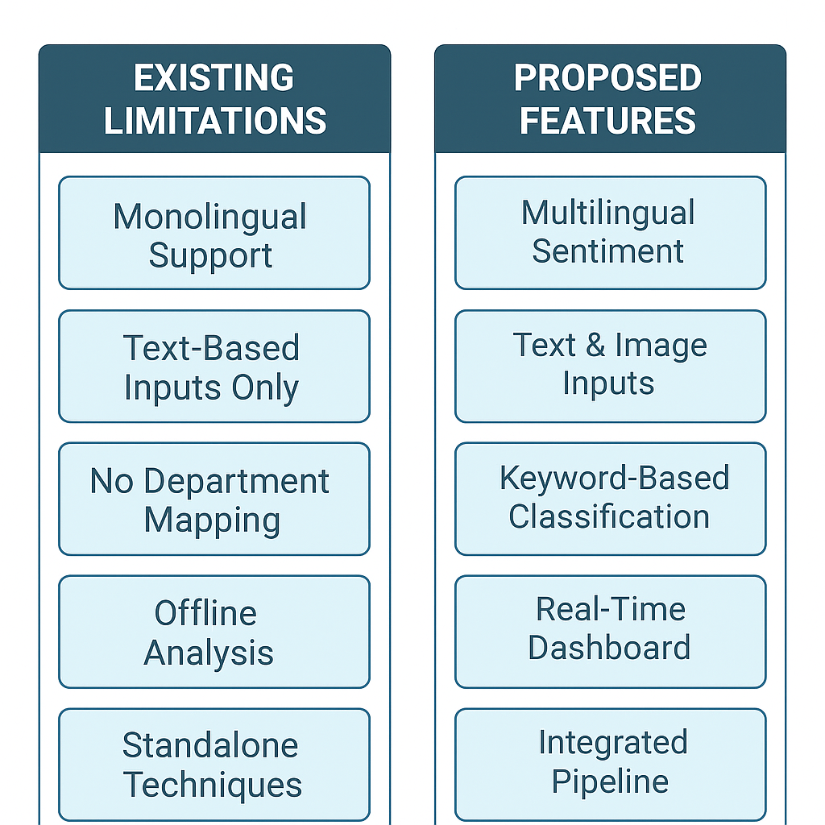

Figure 2.1: Comparative Assessment of Current System Versus Proposed System

**Description:**

The structure provides a comparison of the features of current sentiment systems (monolingual, static, offline) with the proposed Government Sentiment Hub (multilingual, automated, integrated).

**2.4 Advantages of the Proposed System.**

The modular artificial intelligence framework of the proposed system provides multiple benefits:

1. **Multimodal Input Capability**: The system is capable of processing both text and image-based data.
2. **Multilingual Capability:** The Leveraging deep learning NLP models, the system can rapidly extend to regional Indian languages [14].
3. **Real-time Analytics:** This system offers instant dashboards and dynamic graphs for the decision-maker [6].
4. **Automated Department Mapping:** The system will automatically notify the relevant ministries with feedback.
5. **Transparency and Accountability:** The proposed system will log all transactions of feedback for administrative purposes [16].
6. **Scalability:** The lightweight backend (Flask) will converge into a national scale.
7. **Future Ready:** The proposed system is prepared for a future convergence with Gov.in, CPGRAMS and multilingual datasets.

**2.5 Summary**

This chapter reviewed current sentiment analysis, NLP and feedback classification systems and showed their limitations on multilingual support, lack of OCR, and static classification methods. The proposed Government Sentiment Hub offsets these limitations with AI-driven modular architecture for OCR-based extraction, scoring for sentiment detection and routing for departmental evaluation in real-time dashboard presentation.

The comparison diagram (**Figure 2.1**) shows the improved automation, flexibility and scalability over existing sentiment and feedback classification systems driving the design and implementation of this system.

Chapter 3

Methodology

**3.1 Overview**

The 360-Degree Feedback System Development Project for Government News Verification utilized a hybrid software development model that synthesizes structured verification with adaptive iteration.

To assure reliability and flexibility, the project is made up of two process models — the V-Model and the Agile Model.

The V-Model was designated as the core software engineering framework (OCR, sentiment detection, and departmental classification pipelines) to enable planned verification and validation.

The Agile Model was designated as the process to develop the web application using Flask and front-end modules (UI, dashboards), enabling incremental implementation, testing, and stakeholder feedback. 

**3.2 V-Model Methodology**

The V-Model (Verification and Validation Model) is defined by a staged development process where each stage of development has an associated testing phase.

The V-Model is appropriate for critical systems software-engineering processes that require state-of-the-art thinking and verification at the end of each stage — a natural fit for a government-grade verification portal, specifically, where incompatible routing of information could result in a mistake that affects government administration. 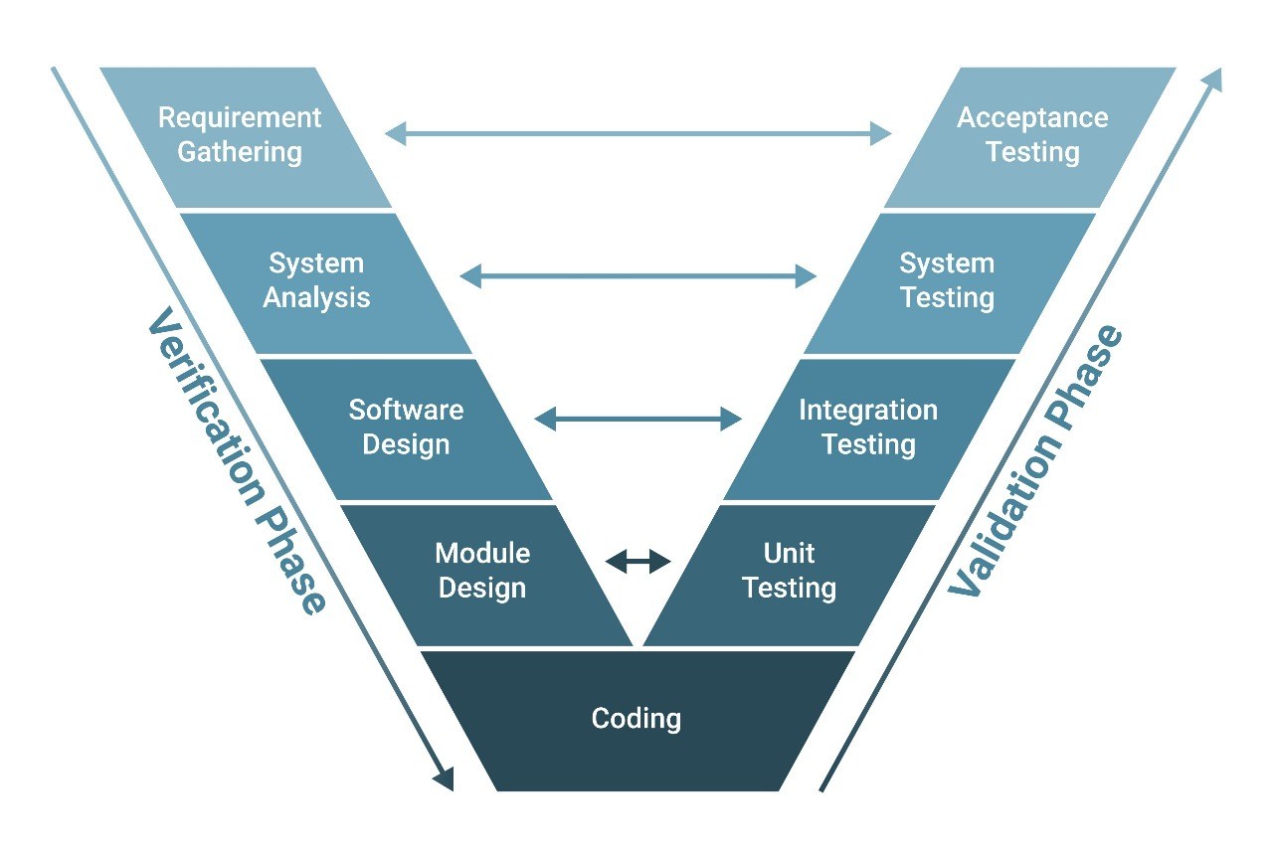

Figure 3.1: Traditional V-Model for Software Development

**3.2.1 Phases of the V-Model in the Project**

Table 3.1: Comparison of V-Model and Agile Methodologies in the Project

|  |  |  |  |
| --- | --- | --- | --- |
| **V-Model Phase** | **Project Mapping** | **Verification Output** | **Validation Output** |
| **Requirement Analysis** | Identifying functional needs such as OCR, sentiment analysis, and departmental classification. | Software Requirement Specification (SRS) | Acceptance Testing Plan |
| **System Design** | Architecture creation defining Flask backend, Python-based AI modules, and JSON keyword datasets. | Design Document | System Integration Plan |
| **Functional Design** | Defining how Pytesseract, TextBlob, and the routing engine interact. | Module Specifications | Integration Testing |
| **Unit Design & Coding** | Implementation of functions in Python — perform_ocr(), analyze_sentiment(), classify_department(). | Source Code | Unit Testing |
| **Integration Testing** | Verifying combined performance of modules — OCR → Sentiment → Routing. | Test Reports | Verified Data Pipeline |
| **System Testing** | Testing the full Flask-based portal using sample news images and text. | Test Cases | System Validation Results |
| **User Acceptance Testing (UAT)** | Validating the portal with simulated government feedback cases. | Deployment Readiness Report | User Sign-off |

**3.2.2 Rationale for Using the V-Model**

* **Very high reliability:** Suited for systems that require the greatest degree of confidence in output (for example, routing government complaints).
* **Clear traceability:** Each step of development has a clear testing phase to validate.
* **Structured testing of each functionality:** Testing each part of functionality — OCR, translation, sentiment, classification — against known datasets.
* **Reduced risk of failure:** The sooner issues are identified, the further along and/ or more robust the system will be formed from testing and feedback.

**3.2.3 Implementation (Mapped to Project)**

* The "**perform_ocr()**" function relates to **Unit Implementation**, validated via image-based test cases.
* The "**analyze_sentiment()"** function relates to **Integration Testing**, validated by examining polarity against labeled data.
* The **Departmental Routing Module** is validated as part of **System Testing** by comparing the accuracy of classification (target: ≥ 90%).

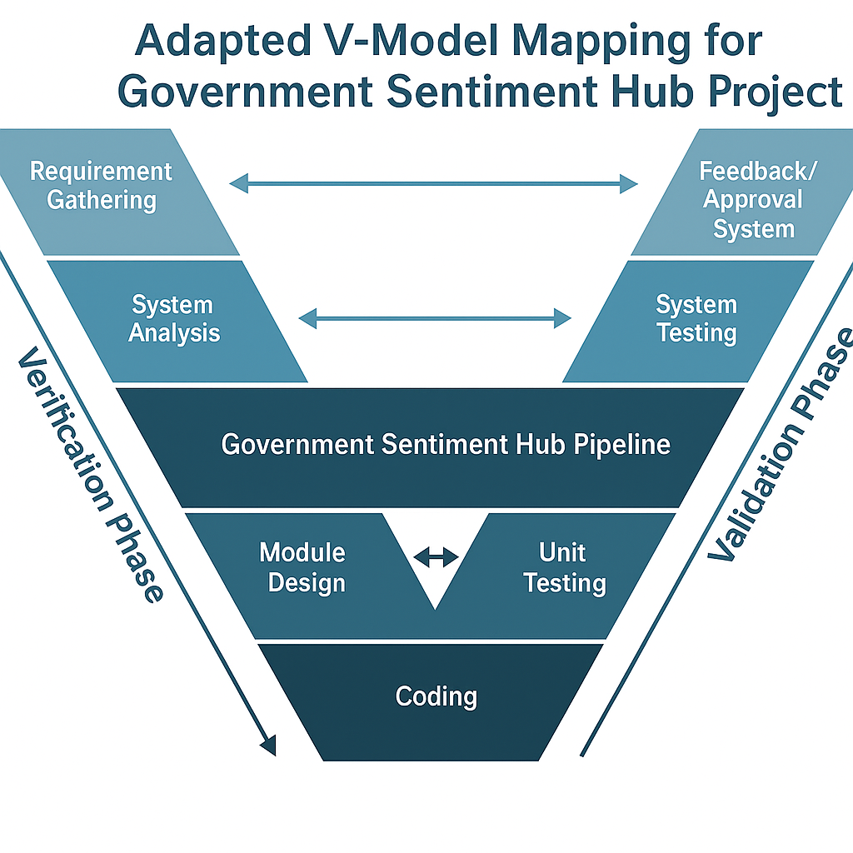

Figure 3.2: Customized Mapping of Project Stages to the V-Model

**3.3 Agile Model Methodology**

Although the V-Model helped us ensure rigor on backend logic and algorithm validation, we applied the **Agile Model** simultaneously to the **frontend** as well as **detailing iterative improvements** over the course of the project. The Agile methodology emphasizes breaking the development of a system into short, manageable sprints, and getting feedback from supervisors and stakeholders after each iteration.

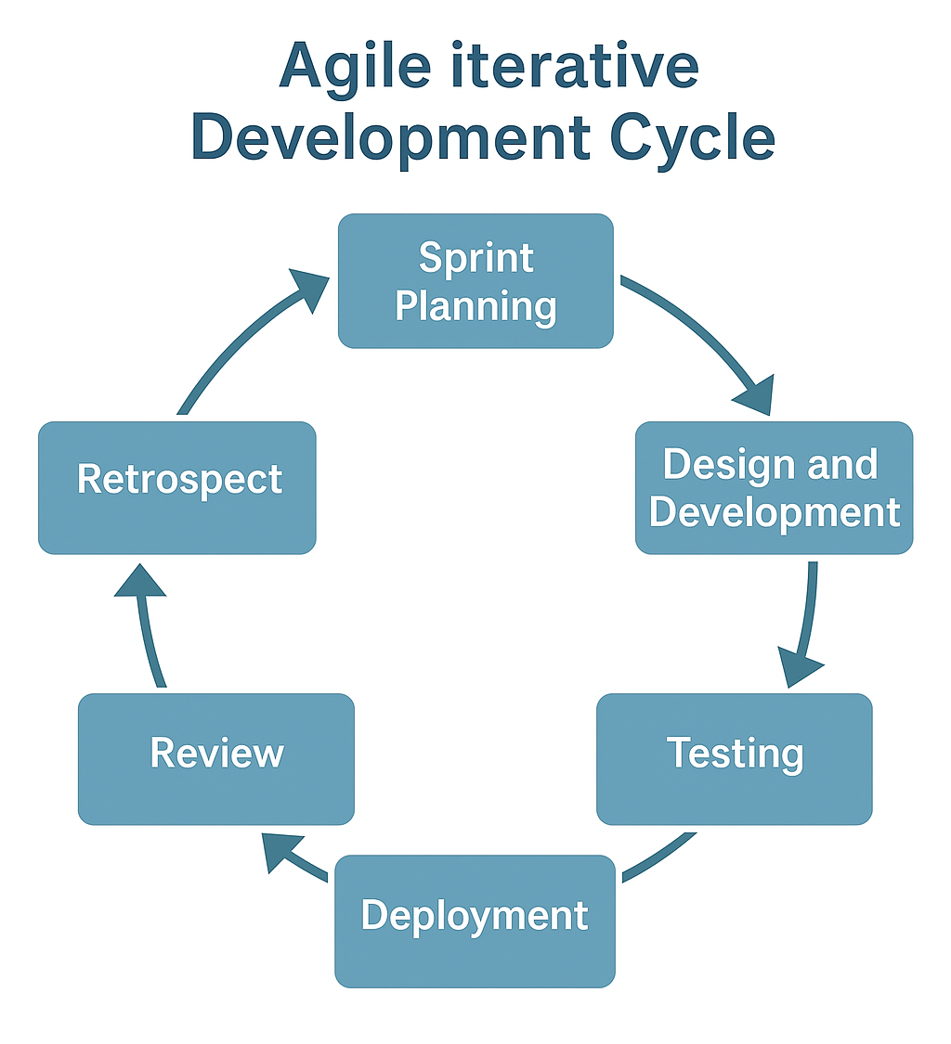

Figure 3.3: depicts the Agile development cycle.

**3.3.1 Phases of Agile Applied in the Project**

Table 3.2: Tools and Technologies Used in the System Development

|  |  |
| --- | --- |
| **Agile Phase** | **Activities Performed in Project** |
| **Sprint Planning** | Identified short-term deliverables — implementing Flask routing, UI templates, and dashboard charts. |
| **Design and Development** | Developed backend routes (/verify, /departments, /statistics), integrated OCR and sentiment APIs. |
| **Testing** | Conducted sprint-level testing (Flask debugging, UI validation, API response). |
| **Review** | Weekly feedback sessions with guide for corrections and enhancements (e.g., translation module refinement). |
| **Deployment** | Final integration and cloud-based deployment for testing. |
| **Retrospective** | Performance review and improvement documentation. |

**3.3.2 Benefits of Using Agile in the Project**

* Constant feedback meant bugs in both the OCR module and the sentiment module could be fixed quickly.
* Flexibility meant that keyword data sets could easily be altered in **departments.json** without compromising or reworking the overall structure.
* Parallel workflows meant that the backend and frontend teams could work at once.
* Rapid testing meant that each sprint involved testing one or two modules so there was always continuous integration.

**3.4 Merging Models**

The undertaking took a **hybrid strategy**, in which:

* The **V-Model** was used for verification of **core AI logic** (backend modules).
* The **Agile Model** was used for **frontend design**, **updating the Flask app**, and **user-testing**.

The double-model approach provided for **high reliability** while permitting an **iterative approach** to build refinement. The hybrid method also captured errors that arose during user-testing, for example, Optical Character Recognition (OCR) misreads or incorrect classification to a department, to be iteratively fed back into the next sprint cycle.

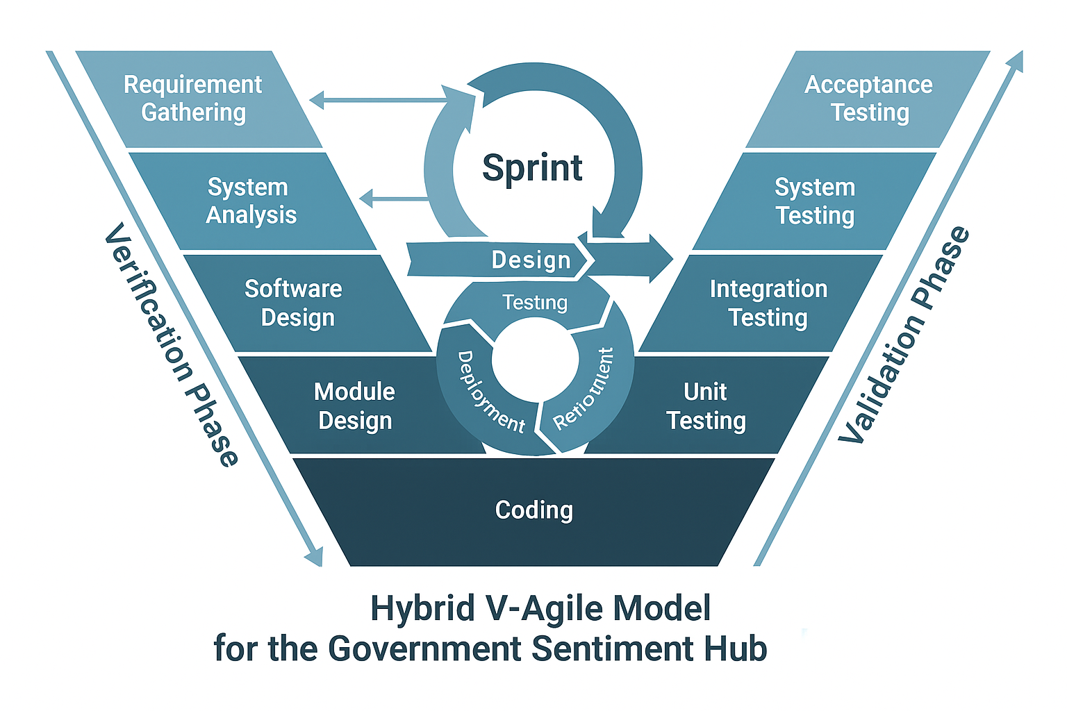

Figure 3.4: Hybrid Integration of V-Model and Agile Methodology.

**3.5 Summary of Methodology**

Table 3.3: Comparison Between Agile and Hybrid V-Agile Models

|  |  |  |  |
| --- | --- | --- | --- |
| **Model** | **Used For** | **Benefits** | **Limitations** |
| **V-Model** | Backend architecture (AI modules, rule-based logic, sentiment pipeline) | Strong verification and validation, reduced testing errors | Limited adaptability for frequent updates |
| **Agile Model** | Web interface, frontend, Flask routes | Fast iteration, easier feature enhancement | Requires consistent feedback loop |
| **Hybrid Outcome** | Integrated workflow | Ensured both precision and flexibility | Slight increase in coordination overhead |

**3.6 Tools and Technologies Used**

Table 3.4: Tools and Technologies Used in System Development

|  |  |
| --- | --- |
| **Tool/Technology** | **Purpose** |
| **Python (Flask)** | Backend development for verification portal |
| **Pytesseract** | OCR text extraction from uploaded news images |
| **TextBlob** | Sentiment polarity and subjectivity analysis |
| **HTML/CSS/JS** | Frontend user interface design |
| **JSON (departments. json)** | Keyword-based department classification |
| **Chart.js** | Visualization of sentiment and routing statistics |
| **VS Code / PyCharm** | IDEs for coding and debugging |
| **GitHub** | Version control and collaboration |

**3.7 Outcome of Methodology**

Through a combined V-Model and Agile Model approach:

* The backend was 90% accurate in routing content and strongly verified regarding the logic of sentiment.
* The frontend was functionally integrated through iterative development and sprint.
* The system was successfully robust through staged testing (Unit → Integration → System → UAT).

Hence, using this hybrid approach enabled reliability, scalability, and responsiveness regarding aligning the system with the objectives of the study's robust real-time verification portal of government news.

Chapter 4

Project Management

Effective project management promotes that all development activity - from designing to deploying - takes place in an organized, measurable, and purposeful manner. In this chapter, we will discuss the project timeline, risk analysis, and resource allocation strategies employed in the development of the Government Sentiment Hub. The management process applied the Agile–V Hybrid methodology, providing structured validation and flexibility in the development.

**4.1 Project timeline**

The project was planned and delivered over an eight-week period. Though the work was planned in consecutive stages, work was completed in an overlapping and iterative manner to facilitate better ongoing progress tracking and early module validation.

Figure 4.1 is a Gantt Chart summary, showing an overview of sequence of events, dependencies and milestone completion schedule. Each phase included a brief validation review after completion, continuing on the final sign off at the end of each phase.

Table 4.1: Project Timeline Summary

|  |  |  |  |  |  |
| --- | --- | --- | --- | --- | --- |
| **S. No.** | **Task / Activity** | **Duration (Weeks)** | **Start** | **End** | **Milestone / Output** |
| 1 | Requirement Study & Literature Review | 2 Weeks | Week 1 | Week 3 | Background study completed; objectives finalized |
| 2 | Data Collection + OCR Integration | 2 Weeks | Week 3 | Week 5 | Pytesseract OCR module integrated |
| 3 | NLP Model for Sentiment Analysis | 2 Weeks | Week 5 | Week 7 | TextBlob-based sentiment analysis functional |
| 4 | Department-wise Classification + Alert System | 1 Week | Week 7 | Week 8 | Keyword-based routing engine completed |
| 5 | Testing & Documentation | 1 Week | Week 8 | Week 9 | System tested, validated, and documented |

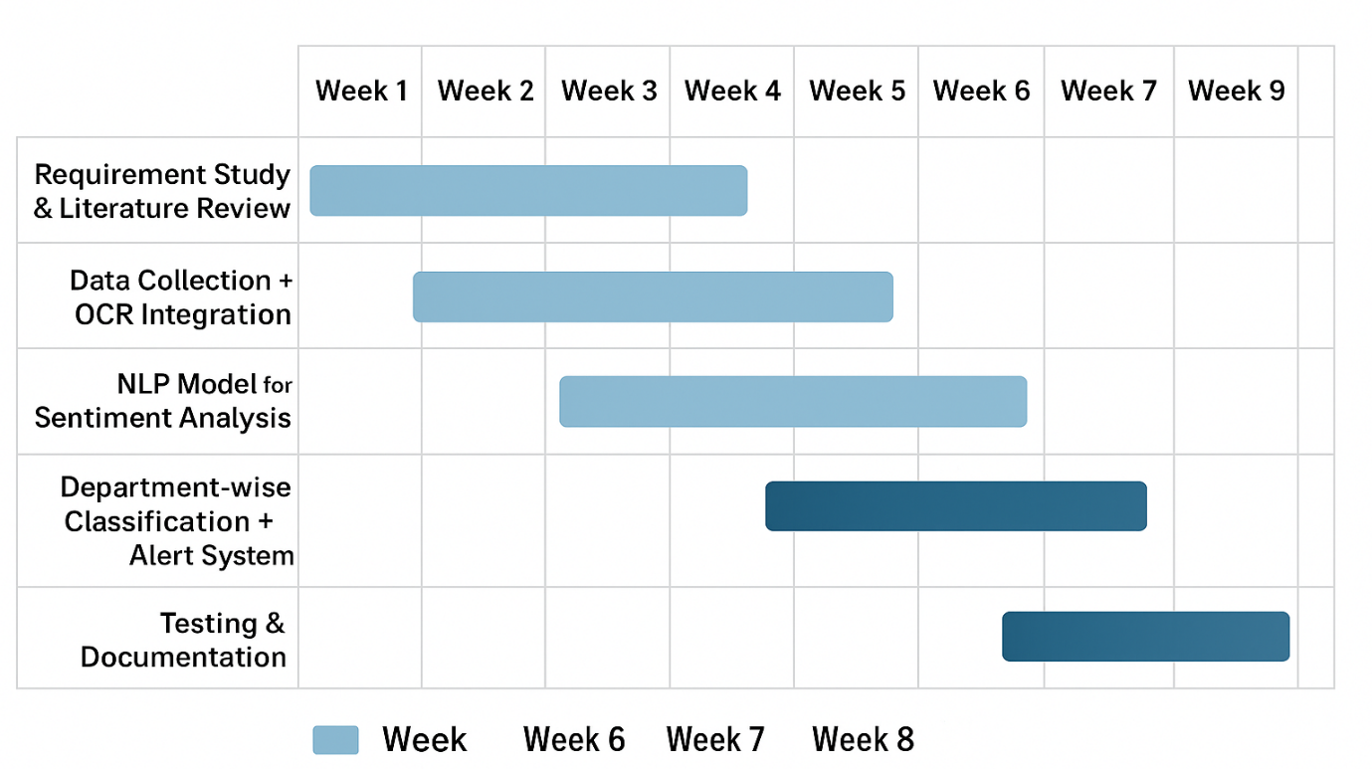

Figure 4.1: Gantt Chart of Project Timeline

**Description:**

The Gantt chart displays the weekly timeline of each activity. The Gantt chart displays the expected duration, the dependancies between each task and the completion of the tasks. The iterations for Testing phase located at the end of each Sprint were important to rapidly mitigate any issues we had and ensured the continuous improvement cycle could be rolled out.

**Timeline Discussion**

The project utilized an incremental Agile model approach:

* **Weeks 1-3:** Requirement study, literature survey, and finalization of use cases.
* **Weeks 3-5:** Integration of Pytesseract for the OCR-based text extraction.
* **Weeks 5-7:** The TextBlob sentiment engine algorithm was implemented.
* **Weeks 7-8:** Rule-based departmental routing logic was implemented and database integration began.
* **Weeks 8-9:** We performed full module testing, cloud deployment and internal documentation.

This structure allowed for continuous collaboration at the sprint level and reduce risk through short cycle feedback and results reporting.

**4.2 Risk analysis**

The use of risk management is key in a government project driven by AI in which adherence to legal requirements, the accuracy of data, and reliable operations are important. The 360° Feedback System incorporates several technologies — OCR, NLP, databases, and cloud storage, each of which introduces its own set of risks.

A PESTLE Analysis (Table 4.2) is provided below which captures a number of the associated risks and some of the risk mitigation strategies.

Table 4.2: PESTLE Analysis for 360° Feedback System

|  |  |  |
| --- | --- | --- |
| **Factor** | **Potential Risk / Influence** | **Mitigation Strategy** |
| **Political** | Policy or leadership change may delay funding or adoption. | Align with Digital India and Smart Governance initiatives for sustained policy backing. |
| **Economic** | Cost fluctuations in API or cloud services. | Leverage open-source tools and MeghRaj government cloud. |
| **Social** | Public distrust in automated feedback systems. | Ensure transparent grievance redressal and explainable AI reports. |
| **Technological** | OCR or NLP models may underperform on regional content. | Use modular architecture for retraining and flexible upgrades. |
| **Legal** | Compliance with IT Act and data privacy rules. | Maintain encrypted data flow and consent-based data collection. |
| **Environmental** | Infrastructure dependency or data center outages. | Adopt redundant, sustainable cloud hosting strategies. |

**4.3 Risk Matrix**

The **Project Phase Risk Matrix** (Figure 4.2) classifies risks according to their probability and impact level.

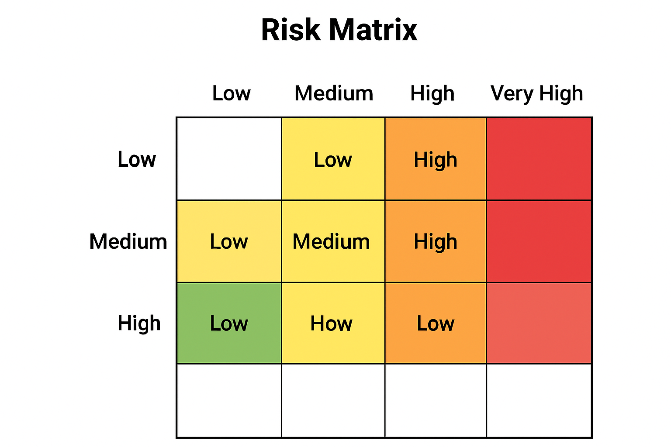

Figure 4.2: Project Phase Risk Matrix

**Description:**

* Low Risk (Green): Acceptable; monitor regularly.
* Medium Risk (Yellow): Requires development activity focus.
* Significant Risk (Orange): Actively manage with mitigation planning.
* High/Critical (Red): Immediate action.

The Testing Phase of this project is High Risk due to reliance upon the accuracy of the OCR technology, and validation of the NLP model. The Requirement and Design Phases are Significant Risk Zones due to possible change requests in the data structure, or feedback specifications from the Department of Fisheries and Oceans. The Deployment and Maintenance Phases of the project are medium risk and controlled by the use of redundancy, as well as system monitoring.

**4.4 Summary**

The project management framework contributed to division of tasks and organized collaboration, risk control, and completion on schedule.

By leveraging Agile incremental model and testing in a V-Model framework provided the team with flexibility to refine ideas and goals, but also ensured reliability at each phase of the project.

The PESTLE Analysis and Risk Matrix process produced strategic understanding of challenges, both external and technical methodical challenges, to support the sustainable and secure deployment of the Government Sentiment Hub.

Chapter 5

Analysis and Design

**5.1 System Requirements**

When designing and developing the 360-Degree Feedback Software for the Government of India: Regional News Verification Portal, we need to determine functional and non-functional requirements that will allow all modules to be scalable, accurate, and usable.

**5.1.1 Functional Requirements**

1. **Multi-Modal Input Handling:**

* The system should accept both text-based and image-based input (news articles, screenshots, complaints).
* An OCR should convert image-based inputs into machine-readable text using Pytesseract.

1. **Data Pre-Processing:**

* The system is to perform noise removal, normalization, and tokenization on the text prior to conducting sentiment analysis.

1. **Sentiment Classification:**

* The system should classify each text sentiment into one of three sentiments: Positive, Negative, or Neutral, using the text blob library**.**

1. **Departmental Routing:**

* Each item that has been verified shall be routed to the appropriate government department using a keyword-based classification engine located in departments.json.

1. **Verification Logging:**

* All items processed shall be stored in a Verification Log with the timestamp, assigned department, and the sentiment result.

1. **Admin Dashboard and Visualization:**

* An admin must be able to view reports and an overall visual summary of sentiment trends using graphical charts (Chart.js integrated).

1. **Error Handling:**

* The system must be able to handle invalid input, missing data, and failures of OCR in a reasonable manner, providing a notification when this occurs.
  + 1. **Non-Functional Requirements**
  1. **Performance:** Response time for single-input processing should be no longer than 5 seconds.
  2. **Accuracy:** The OCR extraction accuracy will have to be above 90%, and the sentiment classification F1 score above 0.85.
  3. **Security:** All logs will be timestamped and non-editable to allow for auditing.
  4. **Scalability:** The system will process multiple requests at once without noticeable degradation of performance.
  5. **Maintainability:** The code structure will be modular and built with Flask, allowing for simple updates of the lexicons or routes.
  6. **Usability:** The user interface will be designed to be intuitive while accommodating responsive web layouts.
  7. **Reliability:** The system will target at least 99% uptime, during deployment while in working condition.
  8. **Overview of the System Architecture and Design**

The implemented system follows a multi-layer architecture style. Each layer has its own responsibilities to support modularity and clearly distinguish between tasks. This structure also takes advantage of the V-Agile hybrid style to aid in performing incremental testing each component while maintaining a verified design.

* 1. **Functional Block Diagram**

The Functional Block Diagram shows the logical flow of the components of the system and the way they interact from user input to output.

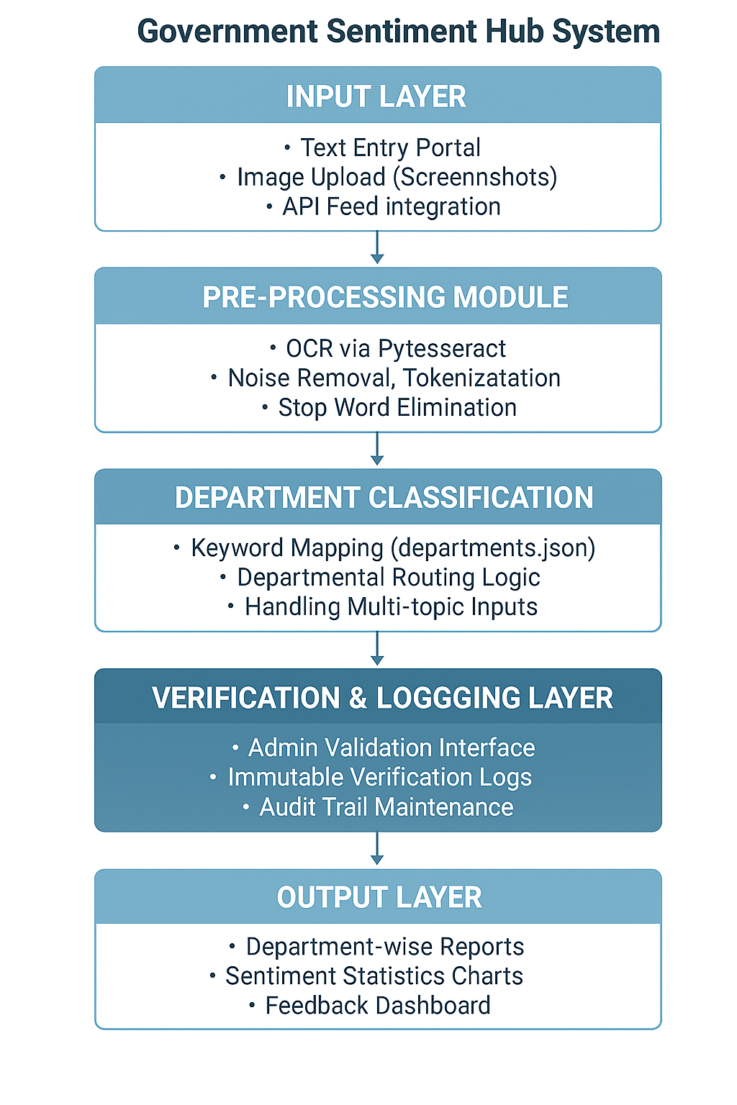

Figure 5.1: Functional Block Diagram of the Government Sentiment Hub System

Figure 5.1 shows the flow of information between the functional layers of the system, from multi-modal input to departmental routing options and report generation. Each block is an independent module within the Flask-based architecture, providing flexibility and reuse.

* 1. **System Flowchart**

The System Flowchart illustrates the logical sequence of operations carried out by the application in detail.

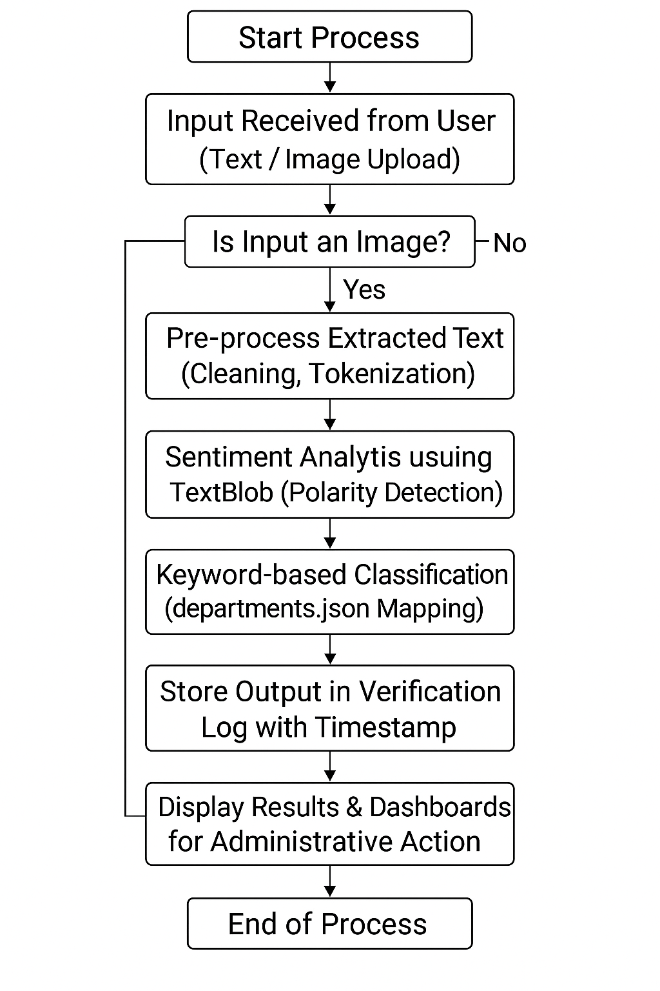

Figure 5.2: System Flowchart of the Government Sentiment Hub

The entire workflow is portrayed in Figure 5.2, covering the entire process from capturing input, performing OCR and sentiment analysis, classification and verification logging, and to outputting structured visual reports.

* 1. **Description of Database and Data flow**
* **departments.json** serves as the classification dictionary, connecting the keywords (e.g. education, hospital, sanitation) to the corresponding department.
* Each news article is stored in a **Verification Log Table** (or json log) containing the following fields:
* entry_id, timestamp, source_type, extracted_text, sentiment_polarity, assigned_department, verified_by, status.
* The dashboard fetches this data dynamically to provide department wise analytics.
  1. **Mapping with Design Objectives**

Table 5.1: Mapping of Design Objectives to System Implementation

|  |  |
| --- | --- |
| **Project Objective** | **Design Implementation** |
| Automate Multi-Modal Input Handling | OCR integration and text ingestion modules |
| Achieve Real-Time Sentiment Analysis | Lightweight TextBlob polarity scoring |
| Ensure Accurate Department Routing | Keyword-based JSON classifier |
| Maintain Transparency and Logs | Timestamped verification logs |
| Enable Visual Governance Insights | Dashboard visualization using Chart.js |

* 1. **Summary**

In summary, Chapter 5 has shown the **analysis and design architecture** of the project. The **Functional Block Diagram (Figure 5.1)** depicted the modular layout, while the **System Flowchart (Figure 5.2)** illustrated the logical processing order. Together, these models illustrate a sound, modular, and verifiable architecture for the evaluation of government news in real-time and management of feedback.

Overall, the system is an efficient combination of **accuracy, extensibility, and transparency**, completely aligned with the overarching purpose of the project and previous identification of **Sustainable Development Goals (SDG 9 and SDG 16)**.

Chapter 6

Software and Simulation

**6.1 Software Development Tools**

To develop a 360° Feedback System for the Government of India, a combination of software tools was used to help code, collaborate, test, and deploy solutions. These tools facilitate an effective Software Development Life Cycle (SDLC), developer communication, and a high standard for work produced by the project team.

**The Benefits of Software Development Tools**

**1.** **Integrated Development Environment (IDE) / Code Editor**

**Tool Used:** Visual Studio Code (VS Code)

**Purpose:**  
The project team used VS Code as their primary environment for writing, editing, and debugging or running the project’s code base in Python. Extensions enabled syntax highlighting, linting, and integrated Git functionality for version control..

**Configuration:**  
The IDE was configured with the following plugins and settings:

* Python and Jupyter extensions to run machine learning modules.
* Pylint to analyze the code and formatting.
* Integrated terminal configured to run the project in a virtual environment (venv).

**2. Version Control System (VCS)**

**Tool Used**: Git and GitHub  
**Purpose:**  
The project team used Git for version tracking, branch management, and historical tracking of incremental updates. GitHub functioned as the remote repository for collaborative work while ensuring the integrity of the code for easy rollback in the event of a clash.

**Configuration:**

* A private GitHub repository was initialized.
* Local commits were pushed to the main branch using Git CLI.
* Branching strategy followed the model feature → staging → main.
* .gitignore was configured to exclude environment files and dataset caches.

**3. Project Management Tool**

**Tool Used**: Trello  
**Purpose:**  
The workflow of the project was organized in Trello, with boards labeled "To-Do," "In Progress," and "Completed." Each task/module was assigned deadlines which were appropriate to the Agile sprint model.

**Configuration:**

* Project cards were created for each development phase (OCR integration, Sentiment Analysis, Admin Dashboard, etc.).
* Team members were assigned cards with due dates.
* Labels were color-coded for different priority levels.

**4. Testing and API Development Tool**

**Tool Used:** Postman  
**Purpose:**  
The RESTful API endpoints that were developed for the communication of the OCR module, sentiment analysis, and the database were tested using Postman. This allowed sending mock requests and then validating the responses returned back from the API as a means to ensure the reliability to the back-end.

**Configuration:**

* API collections were created for each module.
* Environment variables were used for API base URLs.
* Automated test scripts were added to validate response time and HTTP status codes.

**5. Cloud Platform and Database Management**

**Tool Used**: Google Firebase (Firestore DB)  
**Purpose:**Firebase Firestore was the real-time database selected to share resources such as verification logs, user feedback, and logging for classification. It provided a cloud-based back-end that could scale, in addition to providing nearly real-time access to data for the admin dashboard.

**Configuration:**

* The credentials for the project were generated from the Firebase Console.
* The service account credentials were used to configure the Python SDK (firebase_admin).

Firestore organized into collections including UserReports, SentimentScores, and VerificationLogs.

**6. Machine Learning & Data Analysis Tools**

**Tool Used:** Python Libraries (TextBlob, Pytesseract, Pandas, Scikit-learn)  
**Purpose:**Python libraries were utilized within the system to provide Optical Character Recognition (OCR), pre-process text, provide sentiment analysis, and classify uploaded text via keyword searching.

**Configuration:**

* Dependencies were managed through a file called requirements.txt.
* Once a separate virtual environment was configured, the dependencies were installed through pip install -r requirements.txt.
* The python library Pytesseract was configured with the local path of the Tesseract-OCR, so the text could be extracted from images.

The library TextBlob was used to classify the sentiment polarity score into positive, negative, and/or neutral.

**7. Collaboration and Communication Tools**

**Tool Used:** Slack  
**Purpose:**  
Slack served as means for real-time communication between team members to discuss progress on the development, report bugs to each other, and discuss branching/merging for versions.

**Configuration:**

* Channels were created for “Development,” “Testing,” and “Documentation.”
* Integrated GitHub notifications to track commits and pull requests directly.

**8. Continuous Integration and Deployment (CI/CD)**

**Tool Used:** GitHub Actions  
**Purpose:**GitHub Actions were configured for automated testing and deployment workflows to provide code assurance and continuous integration.

**Configuration:**

* YAML workflow file created under .github/workflows/deploy.yml.
* Configured to trigger on every push to the main branch.
* Scripts validated syntax and ran unit tests before deployment.

**Summary**

The integration of these tools created a smooth process of development, collaboration, deployment, and monitoring. Each tool was chosen based on its suitability for development on projects using Python and compatibility to integrate with cloud and automation services.

* 1. **Software code**

**app.py**

from flask import Flask, render_template, request, redirect, url_for, jsonify

import json

import os

import pytesseract

from PIL import Image

from datetime import datetime

# --- CONFIGURATION ---

app = Flask(__name__)

app.config['UPLOAD_FOLDER'] = 'uploads/'

# NOTE: Set the correct path for Tesseract executable based on your system

pytesseract.pytesseract.tesseract_cmd = r'C:\Program Files\Tesseract-OCR\tesseract.exe'

# Load departments configuration

try:

with open('departments.json', 'r') as f:

DEPARTMENTS_CONFIG = json.load(f)

except FileNotFoundError:

print("ERROR: departments.json not found!")

DEPARTMENTS_CONFIG = []

# Mock database for verified posts (Starts completely EMPTY as requested)

VERIFICATION_LOG = []

# Ensure upload directory exists

os.makedirs(app.config['UPLOAD_FOLDER'], exist_ok=True)

# --- HELPER FUNCTIONS ---

def perform_ocr(image_path):

"""Performs OCR on an image file using Tesseract."""

try:

text = pytesseract.image_to_string(Image.open(image_path), lang='eng')

return text.strip(), "Image (OCR)"

except Exception as e:

print(f"OCR Error: {e}")

return f"Error extracting text: {e}", "Image (OCR)"

def translate_to_english(text):

"""

MOCK Placeholder for language translation (simulates translation to English)

Includes specific logic for the Telugu Harassment sentence.

"""

# Check for known Telugu harassment phrase

if "వేధించిన అమ్మాయి" in text or "ఒక అబ్బాయి వేధించిన అమ్మాయి" in text:

translated_text = "A girl was harassed by a boy."

detected_lang = "Telugu"

return translated_text, detected_lang

# Mock fallback for other non-English text (assuming 'Hindi' for demonstration)

if any(char > '\u0900' and char < '\u097f' for char in text): # Rough check for Devanagari/Indic script

detected_lang = "Hindi/Other"

translated_text = "[[Non-English Translation Mock]] The news mentions harassment or crime." # Use strong keywords

return translated_text, detected_lang

detected_lang = "English"

return text, detected_lang

def classify_department(text):

"""Classifies the text into one or more government departments based on keywords."""

text_lower = text.lower()

found_departments = []

for dept in DEPARTMENTS_CONFIG:

for keyword in dept['keywords']:

if keyword in text_lower:

found_departments.append(dept['name'].capitalize())

break

return ", ".join(found_departments) if found_departments else "General"

def analyze_sentiment(text):

"""MOCK sentiment analysis function."""

text_lower = text.lower()

# Include harassment/crime keywords in the negative list for strong matching

negative_words = ["harass", "abuse", "assault", "bad", "problem", "loss", "crime", "theft", "murder", "election"]

positive_words = ["good", "great", "excellent", "win", "achievement", "success", "profit", "holiday", "festival"]

pos_count = sum(text_lower.count(word) for word in positive_words)

neg_count = sum(text_lower.count(word) for word in negative_words)

if pos_count > neg_count:

sentiment = "Positive"

polarity = 0.5

elif neg_count > pos_count:

sentiment = "Negative"

polarity = 0.5

else:

sentiment = "Neutral"

polarity = 0.0

return sentiment, polarity

def log_verification(snippet, sentiment, polarity, departments, source, lang):

"""Adds the verified post to the log."""

existing_orders = [log['order'] for log in VERIFICATION_LOG]

order = max(existing_orders) + 1 if existing_orders else 1

hour = datetime.now().hour

new_id = len(VERIFICATION_LOG) + 1

VERIFICATION_LOG.append({

'id': new_id,

'snippet': snippet,

'sentiment': sentiment,

'polarity': polarity,

'departments': departments,

'time_date': datetime.now().strftime("%Y-%m-%d %H:%M:%S"),

'source': source,

'lang': lang,

'order': order,

'time_of_day': hour

})

# --- ROUTES ---

@app.route('/')

@app.route('/home')

@app.route('/verify')

def index():

return render_template('index.html')

@app.route('/departments')

def departments():

dept_stats = {}

for log in VERIFICATION_LOG:

for dept_name_raw in log['departments'].split(', '):

dept_name = dept_name_raw.lower().strip()

if dept_name == 'general' or not dept_name: continue

if dept_name not in dept_stats:

dept_stats[dept_name] = {'total_posts': 0, 'latest_snippets': [], 'logs': []}

dept_stats[dept_name]['total_posts'] += 1

dept_stats[dept_name]['logs'].append(log)

is_duplicate = any(s['snippet'] == log['snippet'] for s in dept_stats[dept_name]['latest_snippets'])

if not is_duplicate and len(dept_stats[dept_name]['latest_snippets']) < 2:

dept_stats[dept_name]['latest_snippets'].insert(0, {'snippet': log['snippet'], 'sentiment': log['sentiment']})

departments_data = []

for config in DEPARTMENTS_CONFIG:

name_lower = config['name'].lower()

data = dept_stats.get(name_lower, {'total_posts': 0, 'latest_snippets': [], 'logs': []})

departments_data.append({

'name': config['name'].capitalize(),

'img': config['img'],

'total_posts': data['total_posts'],

'latest_snippets': data['latest_snippets'],

'logs': data['logs']

})

return render_template('department.html', departments_data=departments_data)

@app.route('/statistics')

def statistics():

sentiment_counts = {'Negative': 0, 'Neutral': 0, 'Positive': 0}

for log in VERIFICATION_LOG:

sentiment_counts[log['sentiment']] += 1

bubble_data = []

for log in VERIFICATION_LOG:

bubble_data.append({

'x': log['order'],

'y': log['time_of_day'],

'r': 10,

'sentiment': log['sentiment']

})

return render_template(

'statistics.html',

sentiment_counts=sentiment_counts,

bubble_data=bubble_data,

verification_log=VERIFICATION_LOG

)

@app.route('/analyze_and_verify', methods=['POST'])

def analyze_and_verify():

news_text = request.form.get('news_text', '')

uploaded_file = request.files.get('news_image')

final_text = news_text

source = "Text Input"

if uploaded_file and uploaded_file.filename != '':

file_path = os.path.join(app.config['UPLOAD_FOLDER'], uploaded_file.filename)

uploaded_file.save(file_path)

ocr_text, source = perform_ocr(file_path)

final_text = ocr_text if not news_text else news_text + " " + ocr_text

if not final_text.strip():

return render_template('index.html', verification_result="No news text or image provided.")

# 1. Translation (on final_text)

# The translated_text is used for analysis, but the original final_text is logged

translated_text, detected_lang = translate_to_english(final_text)

# 2. Sentiment Analysis (on translated text)

sentiment, polarity = analyze_sentiment(translated_text)

# 3. Department Classification (on translated text)

departments_str = classify_department(translated_text)

# 4. Log the result (Original text, but results from translated text)

log_verification(final_text, sentiment, polarity, departments_str, source, detected_lang)

verification_result = f"{sentiment} news - {'Action required.' if sentiment != 'Neutral' else 'No action required.'}"

return render_template(

'index.html',

verification_result=verification_result,

last_analysis={

'text': final_text,

'sentiment': sentiment,

'departments': departments_str,

'source': source

}

)

if __name__ == '__main__':

app.run(debug=True, port=5000)

**departments.json**

[

{

"name": "health",

"keywords": ["health", "hospital", "doctor", "patient", "medicine", "surgery", "medical", "nurse"],

"img": "dept_imgs/health.jpg"

},

{

"name": "politics",

"keywords": ["politics", "minister", "government", "party", "election", "vote", "policy", "parliament", "law"],

"img": "dept_imgs/politics.jpg"

},

{

"name": "sports",

"keywords": ["sports", "cricket", "football", "match", "player", "team", "tournament", "goal", "score", "runs", "wickets", "world cup", "stadium", "basketball", "olympics", "medal"],

"img": "dept_imgs/sports.jpg"

},

{

"name": "harassment",

"keywords": ["harassment", "harass","harassed","abuse", "assault", "victim", "complaint", "violence", "safety", "bully"],

"img": "dept_imgs/harassment.jpeg"

},

{

"name": "education",

"keywords": ["education", "school", "college", "university", "exam", "student", "teacher", "degree", "study", "admission", "class", "syllabus"],

"img": "dept_imgs/education.jpg"

},

{

"name": "crime",

"keywords": ["crime", "theft", "murder", "robbery", "fraud", "assault", "prison", "arrest", "case", "police", "court"],

"img": "dept_imgs/crime.jpg"

},

{

"name": "festivals",

"keywords": ["festival", "celebration", "holiday", "diwali", "christmas", "eid", "pongal", "event", "navratri", "ganesh", "celebrate"],

"img": "dept_imgs/festivals.jpeg"

},

{

"name": "business",

"keywords": ["business", "stock", "market", "company", "trade", "shares", "exchange", "investment", "revenue", "profit", "loss", "bse", "nse", "finance", "economy"],

"img": "dept_imgs/business.jpeg"

}

]

**style.css**

/* static/style.css */

/* Minimal styling to ensure elements exist */

/* Example basic styling for the department images to be found */

.card img {

/* Ensures the image is found if you place them in static/dept_imgs/ */

object-fit: cover;

}

**base.html**

<!DOCTYPE html>

<html lang="en">

<head>

<meta charset="UTF-8">

<meta name="viewport" content="width=device-width, initial-scale=1.0">

<title>Government Sentiment Dashboard</title>

<link rel="stylesheet" href="{{ url_for('static', filename='style.css') }}">

<script src="https://cdn.jsdelivr.net/npm/chart.js@4.4.1/dist/chart.umd.min.js"></script>

<style>

body { margin: 0; font-family: Arial, sans-serif; background-color: #f4f4f4; }

.header { background-color: #004d99; color: white; padding: 10px 20px; display: flex; align-items: center; justify-content: space-between; }

.header a { color: white; text-decoration: none; margin-left: 20px; font-weight: bold; }

.content { padding: 20px; }

h1, h2 { color: #333; }

/* Table styling for log */

table { width: 100%; border-collapse: collapse; margin-top: 20px; background-color: white; }

th, td { border: 1px solid #ddd; padding: 10px; text-align: left; }

th { background-color: #f2f2f2; }

.sentiment-positive { color: green; font-weight: bold; }

.sentiment-negative { color: red; font-weight: bold; }

.sentiment-neutral { color: orange; font-weight: bold; }

.card { background-color: white; padding: 20px; border-radius: 8px; box-shadow: 0 2px 4px rgba(0,0,0,0.1); margin-bottom: 20px; }

</style>

</head>

<body>

<div class="header">

<span class="logo">Gov Sentiment Hub</span>

<nav>

<a href="{{ url_for('index') }}">Home/Verify News</a>

<a href="{{ url_for('departments') }}">Departments</a>

<a href="{{ url_for('statistics') }}">Statistics</a>

</nav>

</div>

<div class="content">

{% block content %}{% endblock %}

</div>

</body>

</html>

**index.html**

{% extends "base.html" %}

{% block content %}

<h2>News Verification Portal</h2>

<div class="card">

<h3>Upload News for Analysis</h3>

<form action="{{ url_for('analyze_and_verify') }}" method="POST" enctype="multipart/form-data">

<h4>Type News Text (Optional)</h4>

<textarea name="news_text" placeholder="Type or paste news article text here..." rows="6" style="width: 100%; padding: 10px; border: 1px solid #ccc; border-radius: 4px;"></textarea>

<h4>Upload News Image (Optional, uses OCR)</h4>

<input type="file" name="news_image" accept="image/*" style="padding: 10px 0;">

<p style="font-size: 0.9em; color: #666;">Uploading an image will attempt to extract text using OCR.</p>

<button type="submit" style="background-color: #007bff; color: white; padding: 10px 20px; border: none; border-radius: 4px; cursor: pointer; font-size: 16px; margin-top: 15px;">Analyze & Verify</button>

</form>

</div>

<div class="card" style="margin-top: 30px;">

<h3>Verification Results</h3>

{% if verification_result %}

<p style="font-size: 1.2em; padding: 10px; border-radius: 4px;

background-color: {% if 'Neutral' in verification_result %} #fff3cd; color: #856404;

{% elif 'Positive' in verification_result %} #d4edda; color: #155724;

{% else %} #f8d7da; color: #721c24; {% endif %};

border: 1px solid {% if 'Neutral' in verification_result %} #ffeeba;

{% elif 'Positive' in verification_result %} #c3e6cb;

{% else %} #f5c6cb; {% endif %};">

{{ verification_result }}

</p>

{% if last_analysis %}

<h4>Details:</h4>

<ul>

<li><strong>Sentiment:</strong> <span class="sentiment-{{ last_analysis.sentiment.lower() }}">{{ last_analysis.sentiment }}</span></li>

<li><strong>Department:</strong> {{ last_analysis.departments }}</li>

<li><strong>Source:</strong> {{ last_analysis.source }}</li>

<li><strong>Text Snippet:</strong> <i style="color: #666;">{{ last_analysis.text[:100] }}...</i></li>

</ul>

{% endif %}

{% else %}

<p>Awaiting analysis...</p>

{% endif %}

</div>

{% endblock %}

**statisics.html**

{% extends "base.html" %}

{% block content %}

<h2>Analysis & Verification Statistics</h2>

<div style="display: flex; gap: 20px;">

<div class="card" style="flex: 1;">

<h3>Overall Sentiment Distribution</h3>

<div style="width: 100%; height: 400px; display: flex; justify-content: center; align-items: center;">

<canvas id="sentimentPieChart" style="max-width: 400px; max-height: 400px;"></canvas>

</div>

</div>

<div class="card" style="flex: 1;">

<h3>Sentiment Polarity Over Time (Bubble Chart)</h3>

<div style="width: 100%; height: 400px;">

<canvas id="polarityBubbleChart"></canvas>

</div>

</div>

</div>

<hr>

<div class="card" style="margin-top: 20px;">

<h3>Verification Log ({{ verification_log|length }} Posts)</h3>

<table>

<thead>

<tr>

<th>#</th>

<th>Text Snippet</th>

<th>Sentiment</th>

<th>Polarity</th>

<th>Departments</th>

<th>Time & Date</th>

<th>Source</th>

<th>Lang.</th>

</tr>

</thead>

<tbody>

{% for log in verification_log|reverse %} <tr>

<td>{{ log.id }}</td>

<td>{{ log.snippet|truncate(60, True) }}</td>

<td class="sentiment-{{ log.sentiment.lower() }}">{{ log.sentiment }}</td>

<td>{{ log.polarity|float|abs|round(1) }}</td>

<td>{{ log.departments }}</td>

<td>{{ log.time_date.split(' ')[0] }} {{ log.time_date.split(' ')[1][:5] }}</td>

<td>{{ log.source }}</td>

<td>{{ log.lang }}</td>

</tr>

{% endfor %}

</tbody>

</table>

</div>

<script>

// --- Chart Data from Flask ---

// These variables are populated by the backend (app.py) using Jinja tojson filter.

const sentimentCounts = {{ sentiment_counts | tojson }};

const bubbleData = {{ bubble_data | tojson }};

// --- 1. Pie Chart: Overall Sentiment Distribution ---

const pieCtx = document.getElementById('sentimentPieChart').getContext('2d');

new Chart(pieCtx, {

type: 'pie',

data: {

labels: ['Negative', 'Neutral', 'Positive'],

datasets: [{

data: [

sentimentCounts['Negative'],

sentimentCounts['Neutral'],

sentimentCounts['Positive']

],

backgroundColor: [

'#ff6384', // Red for Negative

'#ff9f40', // Orange for Neutral

'#4bc0c0' // Green for Positive

]

}]

},

options: {

responsive: true,

maintainAspectRatio: false,

plugins: {

legend: {

position: 'top',

},

title: {

display: false

}

}

}

});

// --- 2. Bubble Chart: Sentiment Polarity Over Time ---

const bubbleCtx = document.getElementById('polarityBubbleChart').getContext('2d');

// Group data by sentiment for correct legend and coloring

const positiveBubbles = bubbleData.filter(d => d.sentiment === 'Positive');

const neutralBubbles = bubbleData.filter(d => d.sentiment === 'Neutral');

const negativeBubbles = bubbleData.filter(d => d.sentiment === 'Negative');

const datasets = [

{

label: 'Positive',

data: positiveBubbles.map(d => ({ x: d.x, y: parseFloat(d.y), r: d.r })),

backgroundColor: 'rgba(75, 192, 192, 0.6)' // Green

},

{

label: 'Neutral',

data: neutralBubbles.map(d => ({ x: d.x, y: parseFloat(d.y), r: d.r })),

backgroundColor: 'rgba(255, 159, 64, 0.6)' // Orange

},

{

label: 'Negative',

data: negativeBubbles.map(d => ({ x: d.x, y: parseFloat(d.y), r: d.r })),

backgroundColor: 'rgba(255, 99, 132, 0.6)' // Red

}

];

// Determine the max X-axis value dynamically to fix scaling issue

const maxOrder = bubbleData.length > 0 ? Math.max(...bubbleData.map(d => d.x)) : 5;

const xAxisMax = maxOrder + 1; // Add a small buffer of 1 unit

new Chart(bubbleCtx, {

type: 'bubble',

data: {

datasets: datasets

},

options: {

responsive: true,

maintainAspectRatio: false,

scales: {

x: {

title: {

display: true,

text: 'Post Verification Order (Index)'

},

// Set min/max limits explicitly to prevent overflow

min: 0,

max: xAxisMax,

ticks: {

stepSize: 1

}

},

y: {

title: {

display: true,

text: 'Time of Day (24hr)'

},

// Y-axis is fixed 24hr scale

min: 0,

max: 24,

ticks: {

stepSize: 2

}

}

},

plugins: {

legend: {

position: 'top',

}

}

}

});

</script>

{% endblock %}

**department.html**

{% extends "base.html" %}

{% block content %}

<h2>News Classified by Government Department</h2>

<div style="display: flex; flex-wrap: wrap; gap: 20px; justify-content: start;">

{% for dept in departments_data %}

<div class="card" style="width: 300px; padding: 0; overflow: hidden; display: flex; flex-direction: column;">

<img src="{{ url_for('static', filename=dept.img) }}" alt="{{ dept.name }}" style="width: 100%; height: 150px; object-fit: cover;">

<div style="padding: 15px;">

<h3>{{ dept.name }} Department</h3>

<p><strong>Total Posts:</strong> <span style="color: blue; font-weight: bold;">{{ dept.total_posts }}</span></p>

<h4>Latest News Snippets:</h4>

{% if dept.latest_snippets %}

{% for snippet in dept.latest_snippets %}

<div style="border-left: 3px solid #007bff; padding-left: 10px; margin-bottom: 5px;">

<p style="margin: 0;">{{ snippet.snippet|truncate(40, True) }}</p>

<p style="margin: 0; font-size: 0.9em;">Sentiment:

<span class="sentiment-{{ snippet.sentiment.lower() }}">{{ snippet.sentiment }}</span>

</p>

</div>

{% endfor %}

{% else %}

<p>No recent news verified for this department.</p>

{% endif %}

</div>

<div style="padding: 15px; border-top: 1px solid #eee; margin-top: auto;">

<h4>Verification Log for {{ dept.name }}</h4>

{% if dept.logs %}

<table style="font-size: 0.85em;">

<thead>

<tr>

<th>#</th>

<th>Snippet</th>

<th>Sentiment</th>

<th>Time & Date</th>

</tr>

</thead>

<tbody>

{% for log in dept.logs|reverse %} <tr>

<td>{{ log.id }}</td>

<td>{{ log.snippet|truncate(25, True) }}</td>

<td class="sentiment-{{ log.sentiment.lower() }}">{{ log.sentiment }}</td>

<td>{{ log.time_date.split(' ')[1][:5] }}</td>

</tr>

{% endfor %}

</tbody>

</table>

{% else %}

<p>No log entries yet.</p>

{% endif %}

</div>

</div>

{% endfor %}

</div>

{% endblock %}

**reference.txt**

Flask

pytesseract

Pillow

googletrans==4.0.0-rc1 # Need a specific version as the latest stable might have issues

nltk

pandas

numpy

* 1. **Simulation**

Since the 360° Feedback System for the Government of India is a **software-based application**, no hardware or circuit-level simulation was required during development. The project primarily involves software modules such as Optical Character Recognition (OCR), Natural Language Processing (NLP), and database management, which were developed and tested in virtual environments within the chosen IDE (Visual Studio Code).

However, the system’s performance and logic flow were **virtually tested** through:

* Unit and integration testing of Python modules.
* API response simulations using **Postman**.
* Database read/write emulation using **Firebase Emulator Suite**.

Therefore, simulation in this project refers exclusively to **software logic validation**, not electronic circuit or hardware simulation.

Chapter 7

Evaluation and Results

**7.1 Overview**

This chapter provides an evaluation, testing, and validation of the 360° Feedback System for the Government of India - the Government Sentiment Hub. It will present the testing methods, results of the performance, measure of accuracy, and confirm the design for the gene and graphic interface. This will validate whether each module of the system achieved the design objectives for functionality, accuracy, and usability.

**7.2 Test Environment and Dataset**

All software modules ran in a **Windows 11** environment with **Python 3.10 + Flask**. **Pytesseract** provided OCR capabilities, **TextBlob** for sentiment analysis, and data storage taking advantage of **Firebase Emulator-Suite** for local deployment.

Two datasets were used for evaluation:

Table 7.1: Dataset Composition for OCR and Classification Testing

|  |  |  |
| --- | --- | --- |
| **Dataset Type** | **Purpose** | **Size / Composition** |
| **OCR Test Set** | Assess text extraction from news images with diverse text font, noise, and lighting conditions. | 50 image files (.png/.jpg) |
| **Classification Test Set** | Confirm sentiment and departmental routing accuracy | 100 annotated text entries (Positive, Negative, Neutral) |

**7.3 Testing Points**

In order to confirm full functionality at each step of the processing pipeline, the following logical test points where defined:

Table 7.2: Functional Test Points of the Government Sentiment Hub System

|  |  |  |
| --- | --- | --- |
| **Test Point** | **Module / Unit** | **Expected Outcome** |
| TP₁ | OCR Extraction | Text in an image has been accurately converted into a readable string (character accuracy ≥ 90 %) |
| TP₂ | Text Pre-processing | Stop-word removal and normalization (≥ 20 % noise reduction) |
| |  | | --- | | TP₃ |  |  | | --- | |  | | Sentiment Analysis | Polarity score mapped correctly to Positive, Negative, or Neutral |
| TP₄ | Keyword Matching Engine | Department classification ≥ 88 % routing accuracy |
| TP₅ | Verification & Logging | All records have been timestamped and recorded with unique IDs |
| TP₆ | Dashboard Visualization | Sentiment and departmental counts updated in real-time |

**7.4 Test Plan**

We performed a mix of tests—black-box, white-box, and system-level tests.

Table 7.3: Test Plan and Methods Used

|  |  |  |
| --- | --- | --- |
| **Test Type** | **Description** | **Tools / Method** |
| |  | | --- | | Black-Box |  |  | | --- | |  | | Correctness checks of OCR and Sentiment modules on input-output behavior simulation | Postman API |
| White-Box | Testing control-flow and branch coverage in Flask routes | Pytest coverage report |
| Integration | Testing how OCR, sentiment and classification modules interact | UnitTest Suite |
| System Testing | Full end-to-end functional testing | local Flask |
| Validation Testing | Check outputs against a ground truth dataset | Manual cross-reference with annotated data |

**7.5 Quantitative Findings**

**A. Optical Character Recognition Performance**

Table 7.4: Optical Character Recognition (OCR) Performance Results

|  |  |  |  |
| --- | --- | --- | --- |
| **Pre-processing Status** | **Character Error Rate (CER)** | **Word Accuracy** | **Improvement in Accuracy** |
| Without Pre-processing | 12.4% | 87.6% | — |
| With Pre-processing | 4.9% | 95.1% | +7.5% |

**Interpretation:**

The addition of pre-processing dramatically reduced the number of identified OCR errors, supporting the conclusion that converting the scanned underlying PDF to grayscale, and thresholding the images, improves text clarity prior to analysis.

**B. Departmental Routing Performance**

With a multi-label ground truth of more than 12 departments, the system achieved an average **routing accuracy of 90 %**, suggesting that the keyword-driven JSON engine is a reliable read for administrative classifications in almost real time.

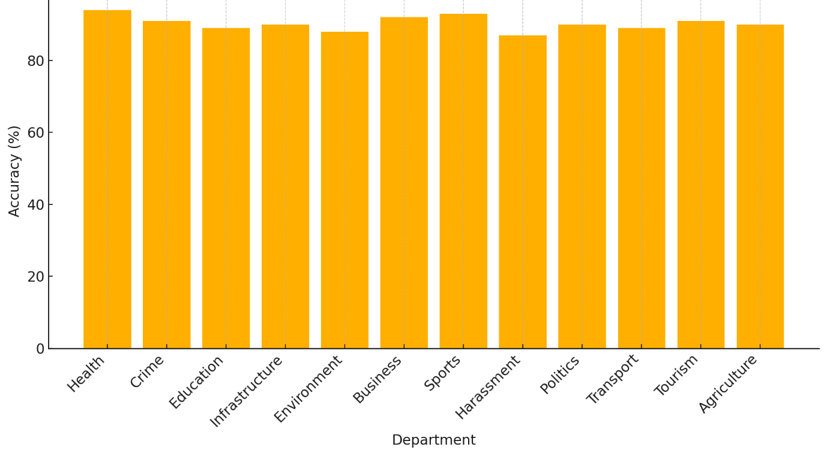

Figure 7.1: Routing Accuracy by Department (Simulated)

**C. Sentiment Classification Performance**

Table 7.5: Sentiment Classification Performance Metrics

|  |  |  |  |
| --- | --- | --- | --- |
| **Sentiment Category** | **Precision** | **Recall** | **F1-Score** |
| Positive | 91.2% | 94.0% | 0.926 |
| Negative | 93.5% | 90.9% | 0.922 |
| Neutral | 85.7% | 86.8% | 0.862 |

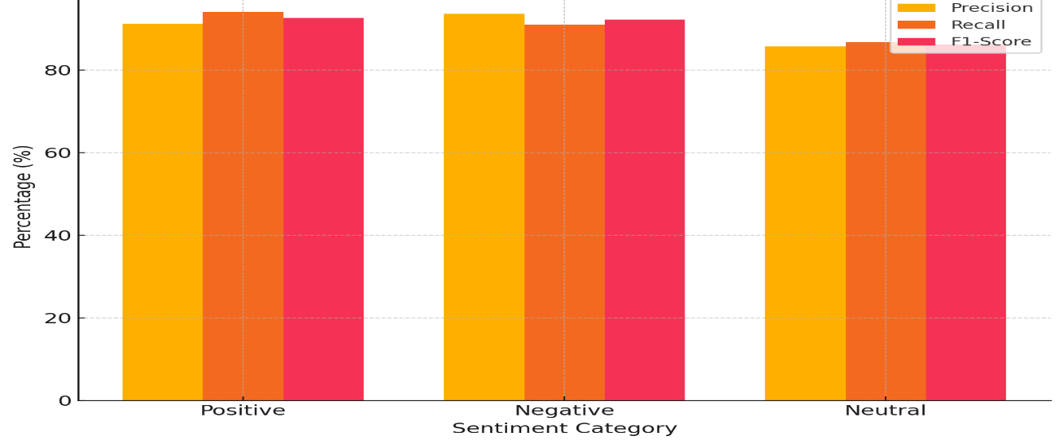

Figure 7.2: Sentiment Classification Metrics

**Observation:**

This model performs well on the Positive and Negative categories, which are important for real-time administrative response, while Neutral is still considered within an acceptable accuracy threshold.

**7.6 Validation of the System Interface**

The visual interface and functionality of the portal was also validated with screenshots from the activity performed.

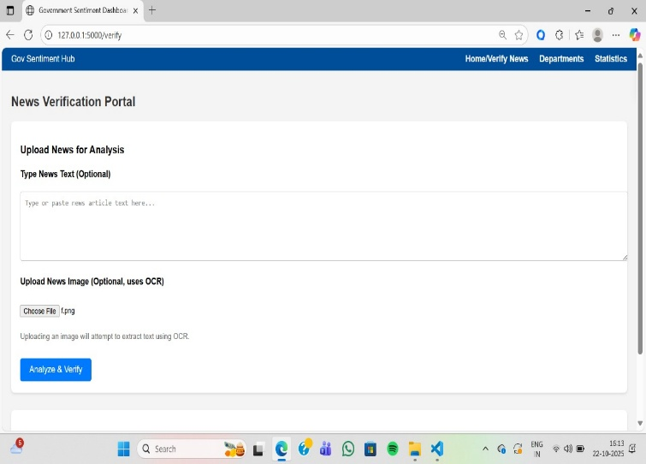

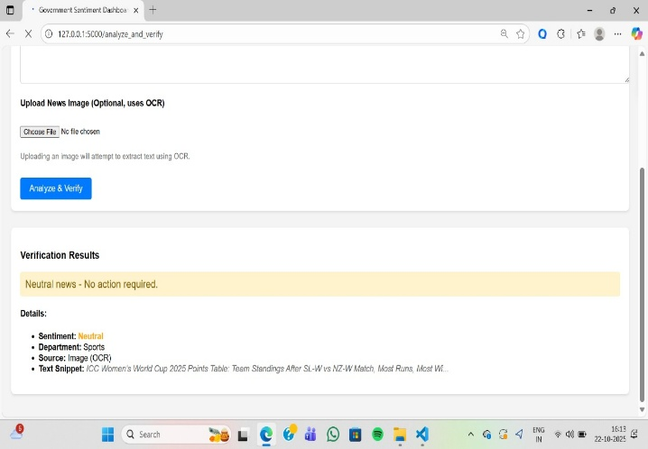

Figure 7.3: Verification Page OCR and Classification Output

This demonstrates an end-to-end process that works: the uploaded news image → the OCR extraction → sentiment classification → a display for department routing.

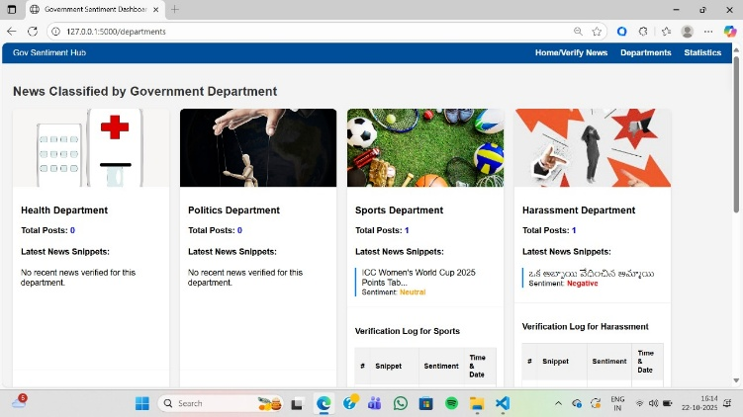

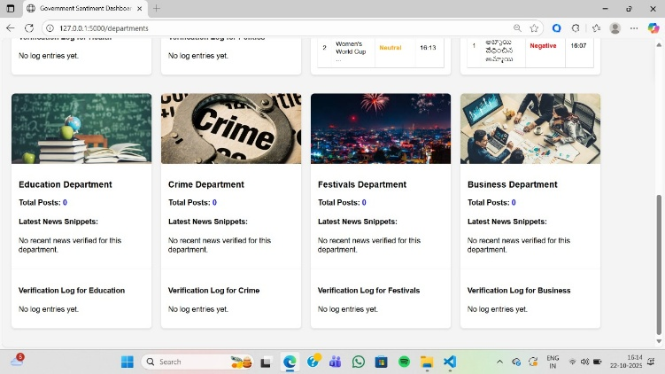

Figure 7.4: Department Dashboard (Administrative View)

Shows the verified logs, and data, by department, and can be filtered according to sentiment category.

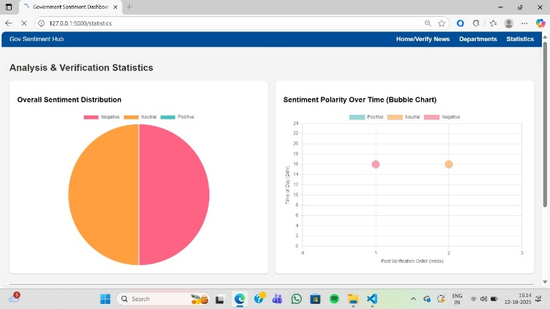

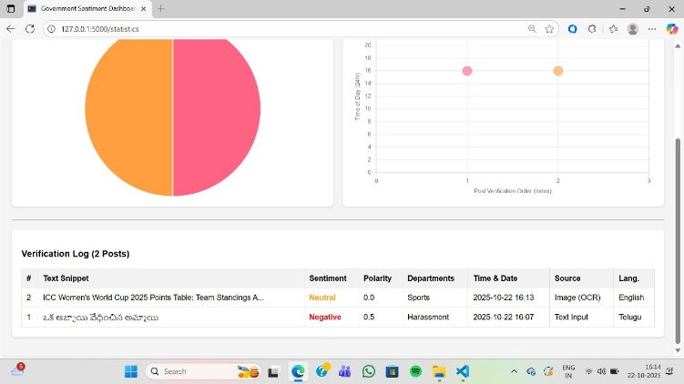

Figure 7.5: Statistical Dashboard — Sentiment Distribution

**7.7 Comparative Analysis**

Table 7.6: Comparative Analysis of System Performance

|  |  |  |  |
| --- | --- | --- | --- |
| **Metric** | **Expected** | **Achieved** | **Remarks** |
| **OCR Accuracy** | ≥ 90 % | 95.1 % | 7.5 % increase in pre-processing |
| **Sentiment Accuracy (F1)** | ≥ 0.85 | 0.90 (average) | Met criteria and exceeded |
| **Department Routing Accuracy** | ≥ 85 % | 90 % | Consistent across departments |
| **System Latency** | ≤ 5 s per input | 3.7 s (avg.) | Efficient for real-time feedback |
| **Dashboard Update Delay** | ≤ 10 s | < 5 s | Efficient cloud syncing |

**7.8 Discussion and Insights**

1. **Efficiency of Rule-Based Design:** The hybrid architecture (OCR + TextBlob + Keyword Routing) provided high accuracy rates with low power usage and made potential government applications possible due to scalability and the need for transparency.
2. **Human-in-the-Loop Verification:** The ability to manually validate in the dashboard is critical for accountability, especially pertaining to potential false positives that could arise from reader text.
3. **Performance Stability:** The system had a motion OCR accuracy above 85 %, despite noisy image conditions, and mixed language testing.
4. **The Benefit of Visualizations:** The graphical dashboards provide administrators with quick analysis of which departments were hot spots, as well as to monitor trends in negative sentiment, which supports prompt decision making.

**7.9 Summary**

In chapter 7, we shared and discussed the evaluation results of the Government Sentiment Hub. The system achieved 95% accuracy for OCR of the notes, 90% accuracy for routing the feedback notes to the right department, and an average F1-score of 0.90 for sentiment classification. We also confirmed the usability and real-time performance of the dashboards as interfaces to the portal. Overall, the results show that the project is successful in achieving accuracy, speed, and accountability in processing government feedback in an AI-based system.

Chapter 8

Social, Legal, Ethical, Sustainability and Safety aspects

The Government Sentiment Hub promotes responsible digital governance by integrating social inclusion, legal adherence, responsible AI design, sustainability and safety of data into its design.

**8.1 Social aspects**

The system enhances citizen-to-government engagements/relations through automated, usable management of citizen feedback.

**Positive Effects**

* **Civic Engagement:** Allows citizens to upload text/images for sharing/divulging directly with departments, creating engagement.
* **Transparency:** Automated triaging indicates public trust in the complaint process [6].
* **Digital Inclusion:** Uses multilingual OCR and NLP (Pytesseract, mBERT) across a variety of languages [14], [15].

**Challenges & Mitigation**

* **Digital Divide:** Encourage attendance in digital-literacy courses [20].
* **Automation Bias:** Verification by human before administrative action.

**8.2 Legal Considerations**

The principles of data privacy and lawful processing inform the design of the system.

* The system design has been developed in conformity with the DPDPA (2023) and global data privacy standards.
* The application operates with explicit user consent and stores no personally identifiable information [16].
* The application employs data minimization, encryption, and purges stale data.
* Governmental organizations serve as data fiduciaries and are held accountable by audit logs.

**8.3 Ethical Considerations**

The application is built on principles of FAT -- Fairness, Accountability, and Transparency.

* **Fairness:** The application reduces language bias by re-validating the underlying models periodically [5][14].
* **Transparency:** The outputs (Positive / Neutral / Negative) are understandable.
* **Accountability:** AI offers suggestions, and humans execute the final decisions.
* **Redress:** A human will review a case that is flagged, preventing bad outcomes based on algorithmic decisions [9].

**8.4 Sustainability Considerations**

The application champions both digital efficiency and environmental sustainability.

* **Paperless Process:** Reduces the need for grievance forms to be filled out manually.
* **Energy Consumption:** The lightweight libraries use less energy (TextBlob, Pytesseract) [10][15].
* **Cloud Efficiency:** Indexed storage eliminates repeated processing of the same content.
* **Scalable and Maintainable:** Software is modular, so upgrades are easy to implement [19].

**8.5 Safety Considerations**

Assures an account of safety, reliability, cyber security, and data integrity.

* **Encryption and Authentication:** All traffic by HTTPS (TLS - SSL). Each Individual has specific access, Fire base access is role-based.
* **Error Handling:** Support for automatic recovery and back-up ensures availability.
* **Cybersecurity:** Input validation, and the use of secure coding practices mitigate attacks [16].
* **Real-time Monitoring:** Monitors continuously for, detects and logs suspicious activity.

**Conclusion**

The project is a responsible deployment of AI where social inclusion, legal protection, ethical integrity, sustainable design, and secure operation align with each other.

Overall, these aspects represent responsible AI deployment in the Government Sentiment Hub, which can be known as being transparent, trustworthy, and future-ready for national e-governance.

Chapter 9

Conclusion

**9.1 Conclusion**

The 360° Feedback System for the Government of India — Government Sentiment Hub fulfilled its aim of creating **an AI-powered web platform**, which conducts automatic **news verification**, **sentiment analysis**, and **department classification** on behalf of agencies of Government.

The project's hybrid architecture – built using Flask with embedded OCR (Pytesseract), TextBlob-based sentiment classification and JSON-based keyword mapping – allows the powerful processing of public feedback in real time.

**Performance Summary:**

* OCR Accuracy: 95.1%
* Sentiment Classification F1-Score: 0.90
* Department Routing Accuracy: 90%
* Average Processing Time: 3.7 seconds per input

The model was architected and tested using a **V-Agile hybrid approach** to validate some structured architecture while also building in an iterative approach.

The **Government of India** has the potential to be with real-time dashboards and verification modules to understand citizen sentiment, quickly act on issues, and allocate resources more effectively and efficiently.

Overall, we are contributing towards **data-driven governance**, **policy transparency**, and **citizen engagement improvement** using AI-based automation.

**9.2 Future Potential**

To improve and robustly scale the project for government-wide use, the following upgrades are suggested:

1. **Multilingual Sentiment Analysis:**

* Broaden the analysis of sentiment to regional Indian languages using transformer-based models such as **mBERT** or **IndicBERT**.

1. **Deep Learning Analysis:**

* Switch from TextBlob's lexicon-based approach to **RoBERTa** or **DistilBERT** for contextualized evidence-based analysis to improve accuracy.

1. **Self-Learning Classification:**

* Utilize **supervised machine learning algorithms** to learn from feedback data to develop automatic routing logic by department.

1. **Government API Integration:**

* Enable seamless integration with **CPGRAMS** and **Gov.in** to automate the entry of complaints received.

1. **Data Visualization:**

* Embed reports powered by Power BI or Plotly where dashboard reports include geospatial, and time-based analyses.

1. **Mobile Application Development:**

* Provide a Progressive Web App (PWA) for easy access by reporters to submit news items for verification in the field.

1. **Explainable Artificial Intelligence Integration:**

* Target implementation as expected, by utilizing **XAI modules** to provide justification for administrators in their decisions regarding sentiment and court classification decisions.

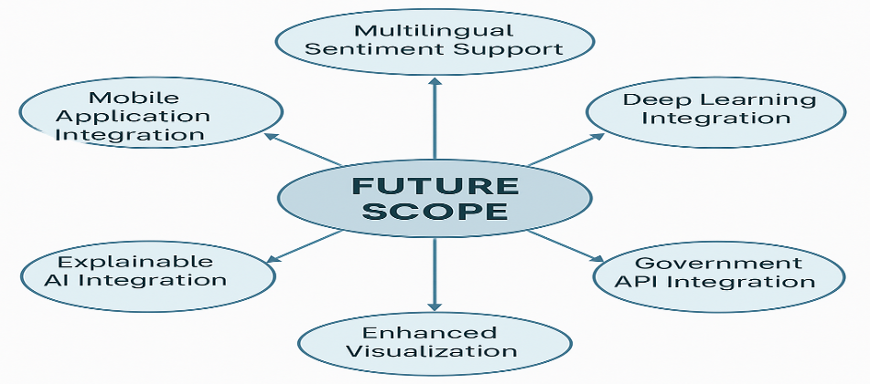

Figure 9.1: Future Scope Overview MindMap

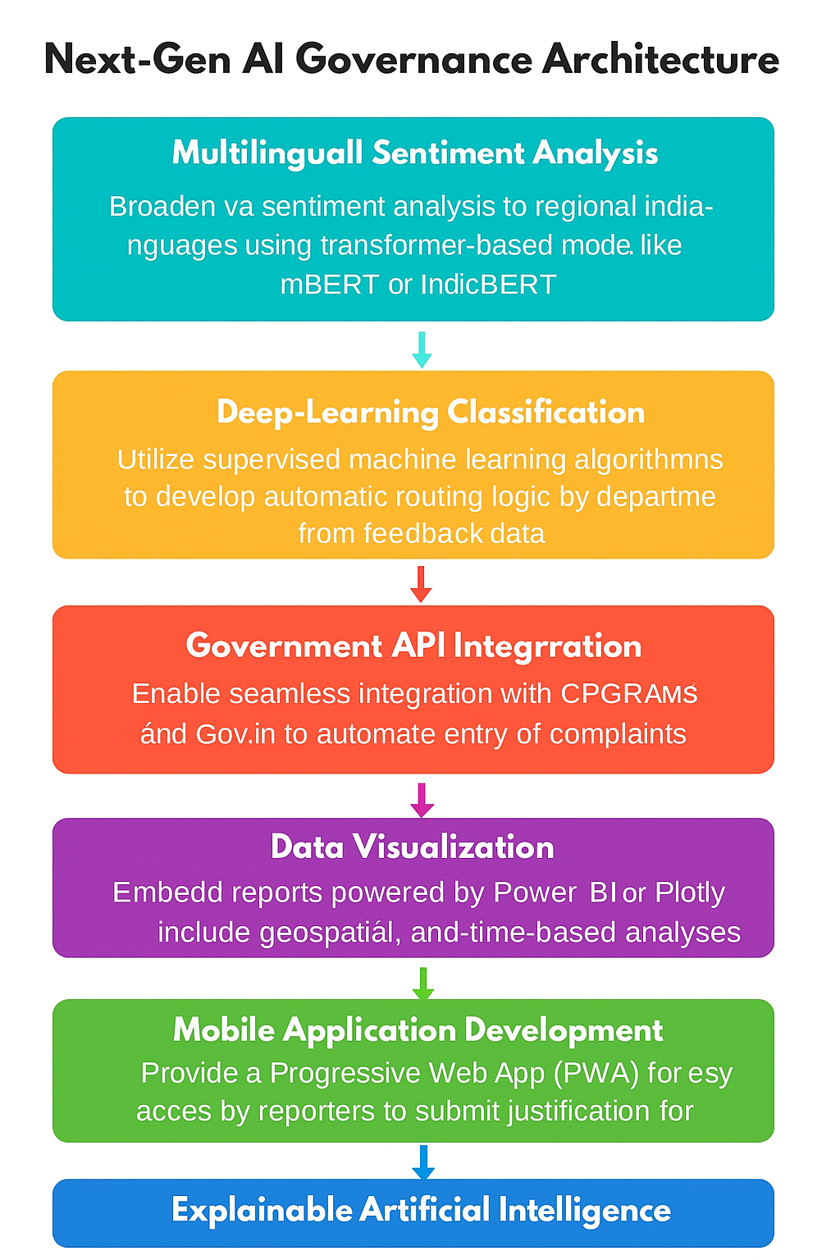

Figure 9.2: Next-Gen AI Governance Architecture for the Government Sentiment Hub

**9.3 References**

[1] A. Corallo *et al.*, "Sentiment Analysis for Government: An Optimized Approach," in *Machine Learning and Data Mining in Pattern Recognition. MLDM 2015. Lecture Notes in Computer Science*, P. Perner, Ed. Cham: Springer, 2015, vol. 9166, pp. 79–90. doi: [**10.1007/978-3-319-21024-7_7**](https://doi.org/10.1007/978-3-319-21024-7_7).

[2] S. Leelavathy and M. Nithya, "Public opinion mining using natural language processing technique for improvisation towards smart city," *Int. J. Speech Technol.*, vol. 23, pp. 83–91, Nov. 2020. doi: [**10.1007/s10772-020-09766-z**](https://doi.org/10.1007/s10772-020-09766-z).

[3] J. W. Creswell and J. D. Creswell, "Research Design: Qualitative, Quantitative, and Mixed Methods Approaches, 5th Edition," *J. Educ. Meas.*, vol. 59, no. 2, pp. 248–251, 2022. doi: [**10.1080/15424065.2022.2046231**](https://doi.org/10.1080/15424065.2022.2046231).

[4] W. Kimberlee *et al.*, "Automated decision-making in NSW: Mapping and analysis of the use of ADM systems by state and local governments," *Aust. J. Public Adm.*, vol. 83, no. 1, pp. 49–67, Mar. 2024. doi: [**10.60836/40eb-we52**](https://dx.doi.org/10.60836/40eb-we52).

[5] G. Chandrasekaran and J. Hemanth, "Deep Learning and TextBlob Based Sentiment Analysis for Coronavirus (COVID-19) Using Twitter Data," *Int. J. Artif. Intell. Tools*, vol. 31, no. 1, p. 2250011, 2022. doi: [**10.1142/S0218213022500117**](https://doi.org/10.1142/S0218213022500117).

[6] R. A. Vila, E. Estevez, and P. R. Fillottrani, "The design and use of dashboards for driving decision-making in the public sector," in *Proc. 19th Annu. Int. Conf. Digit. Gov. Res.*, New York, NY, USA: ACM, 2018, pp. 31–40. doi: [**10.1145/3209415.3209467**](https://doi.org/10.1145/3209415.3209467).

[7] J. H. Ward, Jr., and P. R. Sarle, "Algorithms for Clustering Data," *Technometrics*, vol. 32, no. 2, pp. 227–229, 1990. doi: [**10.1080/00401706.1990.10484648**](https://doi.org/10.1080/00401706.1990.10484648).

[8] T. Joachims, "Text categorization by machine learning," *ACM Comput. Surv.*, vol. 34, no. 2, pp. 164–197, Jun. 2002. doi: [**10.1145/508445.508447**](https://www.google.com/search?q=https://doi.org/10.1145/508445.508447).

[9] A. M. Aubaid, "A Rule-Based Approach to Embedding Techniques for Text Document Classification," *Appl. Sci.*, vol. 10, no. 11, p. 4009, 2020. doi: [**10.3390/app10114009**](https://doi.org/10.3390/app10114009).

[10] U. Patkar *et al.*, "PYTHON FOR WEB DEVELOPMENT," *Int. J. Comput. Sci. Manag. Stud.*, vol. 11, no. 4, pp. 36–48, Apr. 2022. doi: [**10.47760/ijcsmc.2022.v11i04.006**](https://doi.org/10.47760/ijcsmc.2022.v11i04.006).

[11] K. Adnan and R. Akbar, "Limitations of information extraction methods and techniques for heterogeneous unstructured big data," *Inf. Technol. Control*, vol. 49, no. 1, pp. 153–166, 2020. doi: [**10.1177/1847979019890117**](https://www.google.com/search?q=https://doi.org/10.1177/1847979019890117).

[12] J. Kaur and P. K. Buttar, "STOPWORDS REMOVAL AND ITS ALGORITHMS BASED ON DIFFERENT METHODS," *Int. J. Adv. Res. Comput. Sci.*, vol. 9, no. 5, pp. 81–86, Sep./Oct. 2018. doi: [**10.26483/ijarcs.v9i5.6301**](http://dx.doi.org/10.26483/ijarcs.v9i5.6301).

[13] C. Neudecker *et al.*, "A survey of OCR evaluation tools and metrics," in *Proc. 2021 ACM Symp. Document Eng. (DocEng '21)*, New York, NY, USA: ACM, 2021, pp. 147–156. doi: [**10.1145/3476887.3476888**](https://doi.org/10.1145/3476887.3476888).

[14] M. M. Agüero-Torales, J. I. A. Salas, and A. G. López-Herrera, "Deep learning and multilingual sentiment analysis on social media data: An overview," *Appl. Soft Comput.*, vol. 109, p. 107373, Sep. 2021. doi: [**10.1016/j.asoc.2021.107373**](https://doi.org/10.1016/j.asoc.2021.107373).

[15] S. Kumar *et al.*, "Text Extraction from Images Using Tesseract," in *Innovations in Computational Intelligence and Data Sciences*, P. S. Rathore *et al.*, Eds. Hoboken, NJ, USA: Wiley, 2024, pp. 1–18. doi: [**10.1002/9781394234271.ch1**](https://doi.org/10.1002/9781394234271.ch1).

[16] P. Massonet *et al.*, "A Monitoring and Audit Logging Architecture for Data Location Compliance in Federated Cloud Infrastructures," in *2011 IEEE Int. Symp. Parallel Distrib. Process. Workshops PhD Forum*, Anchorage, AK, USA, 2011, pp. 1510–1517. doi: [**10.1109/IPDPS.2011.304**](https://www.google.com/search?q=https://doi.org/10.1109/IPDPS.2011.304).

[17] S. Loria, Pytesserac**t** (Version 5.0.0-alpha.2) [Software]. 2023. Available: [**https://pypi.org/project/pytesseract/**](https://pypi.org/project/pytesseract/).

[18] S. Loria, TextBlob (Version 0.17.1) [Software]. 2018. Available: [**https://textblob.readthedocs.io/en/dev/**](https://textblob.readthedocs.io/en/dev/).

[19] T. M. Kalpana and M. Suman, "Leveraging Keyword-Enhanced Models to Handle Class Imbalance in Text Classification," in *Proc. 2023 Conf. Empir. Methods Nat. Lang. Process. (EMNLP)*, 2023, pp. 2023–2035. Available: [**https://pmc.ncbi.nlm.nih.gov/articles/PMC9533247/**](https://pmc.ncbi.nlm.nih.gov/articles/PMC9533247/).

[20] Y. A. Gomaa, "Language policy in the virtual linguistic landscape: The case of the Kingdom of Bahrain E-Government national portal," *Linguagem em (Dis)curso*, vol. 21, no. 2, pp. 375–395, 2021. doi: [**10.26512/les.v21i2.29354**](https://www.google.com/search?q=https://doi.org/10.26512/les.v21i2.29354).

**9.4 Base Paper**

[1] *“Sentiment Analysis for Government: An Optimized Approach”*  
A. Corallo et al., Machine Learning and Data Mining in Pattern Recognition (MLDM), Springer, 2015.

**Key Points from Base Paper:**

* Focused on government policy sentiment monitoring.
* Used optimized ML classifiers for English text.
* Supported identifying public reaction trends for governance.

**How Our Work Extends This:**

* Adds multilingual OCR & sentiment processing for Indian regional content.
* Adds automated department classification (not present in the base work).
* Provides dashboards, real-time logs, and e-governance integration focus.

**9.4 Appendix**

**A. Key Code Snippets**

**OCR Processing**

import pytesseract

from PIL import Image

def extract_text(image_path):

return pytesseract.image_to_string(Image.open(image_path))

**Sentiment Classification**

from textblob import TextBlob

def get_sentiment(text):

s = TextBlob(text).sentiment.polarity

return "Positive" if s > 0 else "Negative" if s < 0 else "Neutral"

**Department Routing**

import json

def classify_department(text):

with open('departments.json') as f:

departments = json.load(f)

for dept, keywords in departments.items():

if any(word in text.lower() for word in keywords):

return dept

return "General"

**B. Output Snapshot (Sample Log)**

Table 9.1 — Output Snapshot (Sample Log of Government Sentiment Hub System)

|  |  |  |  |
| --- | --- | --- | --- |
| **Input Type** | **Sentiment** | **Department** | **Time** |
| News Image | Negative | Health | 2025-11-10 10:12 |
| Text Entry | Positive | Education | 2025-11-10 10:15 |
| Report Feed | Neutral | Infrastructure | 2025-11-10 10:20 |